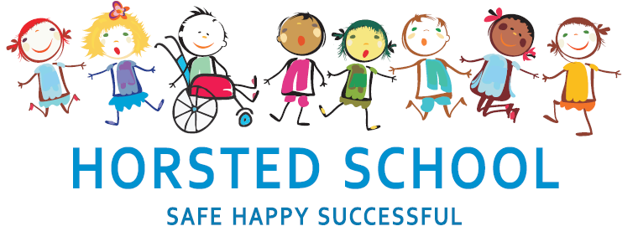
CALCULATION POLICY

Horsted school is a vibrant, safe and welcoming school where we celebrate and welcome differences within our school community. The ability to learn is underpinned by the teaching of basic skills, knowledge, concepts and values with a vision to prepare pupils for a happy and healthy life beyond primary school.
Our vision for Horsted School is that our children will leave us with a genuine enthusiasm for learning and as
- Striving (they will be determined, persevere and they will be resilient);
- Thoughtful (They will be creative, logical and curious about their world and those around them);
- Aspirational (personally, emotionally and academically);
- Respectful (of themselves, others and their environment) and;
- Supportive (of themselves, others and their wider community) individuals.

Aim and purpose
We aim to achieve this through our curriculum’s rich web and in partnership with parents. The curriculum at Horsted is designed to provide an enjoyable, broad and balanced education that meets the needs of all children. It provides opportunities for children to develop as independent, confident and successful learners, with high aspirations, who know how to make a positive contribution to their community and the wider society.
Horsted is an inclusive school. We strive to ensure that all children will be able to access the curriculum or make necessary modifications to it in order to achieve this.

Review date | March 2020
Reviewed by | Leanne Logan
Next Review | March 2023

Approved by

Headteacher: ______________________________________ Date: ___________________

Chair of Governors: _________________________________ Date: ___________________

CALCULATION POLICY
This policy supports the White Rose maths scheme used throughout the school. Progression within each area of calculation is in line with the programme of study in the 2014 National Curriculum.
This calculation policy should be used to support children to develop a deep understanding of number and calculation. This policy has been designed to teach children through the use of concrete, pictorial and abstract representations.
- Concrete representation— a pupil is first introduced to an idea or skill by acting it out with real objects. This is a ‘hands on’ component using real objects and is a foundation for conceptual understanding.

- Pictorial representation – once a pupil has sufficiently understood the ‘hands on’ experiences, they move onto relating them to representations, such as a diagram or picture of the problem.

- Abstract representation—the final step is achieved when a pupil is capable of representing problems by using mathematical notation, for example 12 x 2 = 24.
This is a progressive document, whereby each operation has been broken down into stages. It is imperative that conceptual understanding, supported by the use of representation in an abstract manner, is secure before moving through to the next stage. Reinforcement is achieved by going back and forth between these representations.
Calculation policy: Addition
Key language: sum, total, parts and wholes, plus, add, altogether, more, ‘is equal to’ ‘is
 | Concrete | Pictorial | Abstract
Stage 1: Combining two parts to make a whole  (4+3=7) | Children use blocks or any other object to physically add the two quantities together.  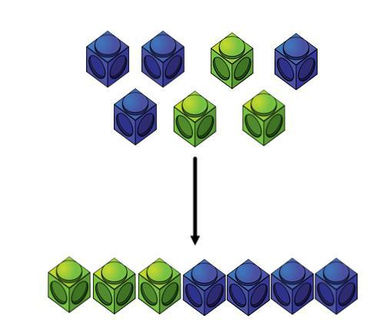 | 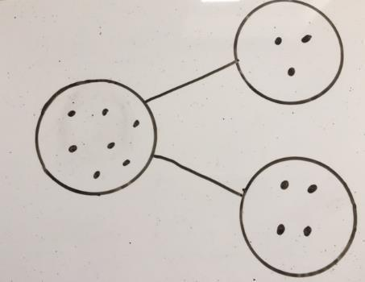  Children move to representing cubes as dots or crosses. The part-whole model is best used to illustrate this method. | Children can use the part-whole method with numbers to show: 4 + 3 = ?  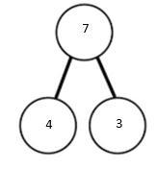  4 is one part, 3 is the other part so the whole totals 7.  This will eventually be replaced with the written expression:  4 + 3 = 7
Stage 2: Counting on using number lines  (4+2=6) | Children first use cubes or Numicon to investigate the concept of a number line.  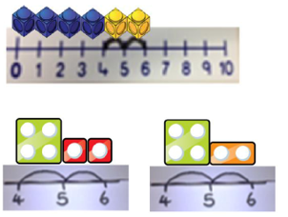 | 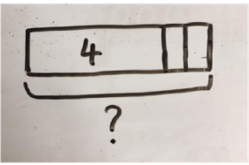  Using a bar model, the children are encouraged to count on rather than just count all the objects. | Using an abstract empty number line, the children are able to answer the following:  What is 2 more than 4?  What is the sum of 4?  What is the total of 4 and 2?  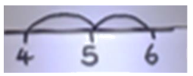  4 + 2 =?
Stage 3: Regrouping to make 10  (6+5=11) | 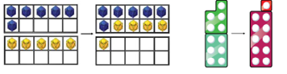  Using ten frames and counters/cubes or Numicon enables the children to identify number bonds to ten and use them when adding. | Children move to drawing their own counters and ten frames.  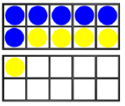 | 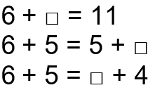  Children progress to developing an understanding of the equals sign and the equality of both sides.
Stage 4: TO + O  (41+8=49) | 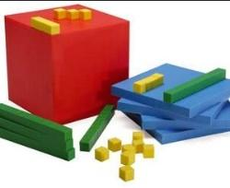  Children continue to develop their understanding of place value and partitioning by using base ten apparatus where 10 individual ones-cubes equal 1 tens-rod.  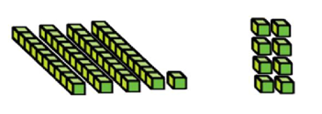 | 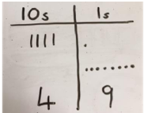  Children move onto representing the base ten equipment as lines for the tens and dots/crosses for the ones. | Children progress to using partitioning to add the following:  41 + 8 =  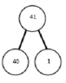  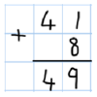  They use the part-whole model to partition 41 and then add 8 to the 1.  They will eventually progress onto using the formal written method.
Stage 5:  TO + TO  (36+25=61) | Children will use base ten to develop their understanding of place value and partitioning.  They will be able to solve 36 + 25 by regrouping.  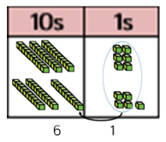  10 lots of ones-cubes will be regrouped to make 1 tens-rod. | 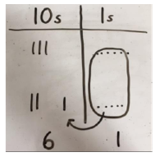  Children move onto representing this in a place value chart with lines for tens and dots/crosses for the ones. | 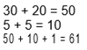  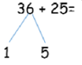  Children will then use their knowledge of number bonds to look for ways to make ten.  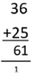  They will then move onto the formal written method where regrouping is shown as a carry.
Stage 6:  HTO + HTO (243+368)  Also applicable to larger place values). | The children will use place value counters to show that they will need to regroup and exchange 10 lots of ones-counters for 1 tens-counter.  Similarly, the 10 lots of tens-counters can be regrouped and exchanged for 1 one-hundred-counter.  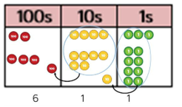 | 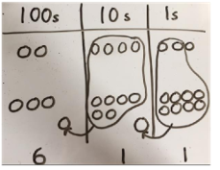  Children will then represent the counters in a place value chart and circle the group they wish to make an exchange with. | 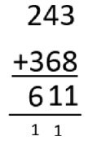  Finally, the children will move onto the formal written method, showing exchanges as carries.

Calculation policy: Subtraction
Key language: take away, less than, the difference, subtract, minus, fewer, decrease.

 | Concrete | Pictorial | Abstract
Stage 1:  Introducing the concept of subtraction (4-3=1) | 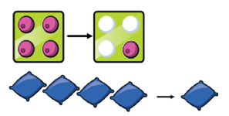  Children will begin to investigate subtraction by using ten frames, Numicon, cubes and other items to physically remove the items. | Children will then progress to represent the physical resources as circles and then cross out the correct amount.  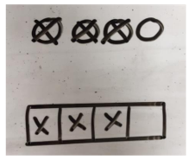  The bar model can also be used to demonstrate this. | 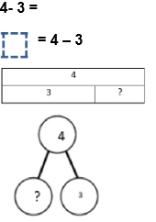  The children will become familiar with seeing this represented in a variety of written ways including an expression, a missing number sentence, bar model and part-whole model.
Stage 2: Counting back  (6-2=4) | Children will start with 6 objects and then remove two. They will be introduced to using a number line to count backwards.  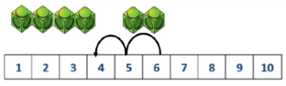 | 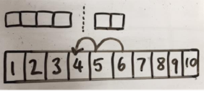  Children will then represent what they see pictorially. | 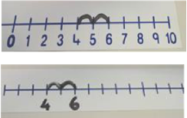  Children will progress to using an empty number line and show their subtraction as jumps.
Stage 3:  Finding the difference  (8-5=3) | Children will begin by using cubes, Numicon or other equipment to physically show the amounts and work out what the numerical difference is.  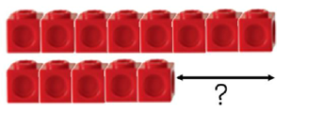 | Children will then draw the cubes/other resources to illustrate what the difference.  The bar model can also be used to demonstrate this concept.  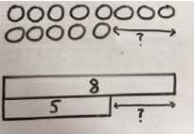 | Children will link difference to subtraction and its written form.  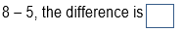  Children will also explore why two pairs of numbers have the same difference e.g.  9-6, 8-5, 7-4  All these numbers have a difference of 3.
Stage 4:  Get to 10 and use knowledge of number bonds to subtract.  (14-5=9) | 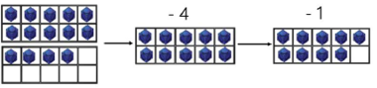  Children will use ten frames and physical resources to work out that once they subtract to 10, they can use number bonds to work out the answer. | 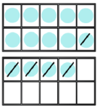  Children will then present the ten-frame pictorially. They will be able to discuss what they have done to get to 10 and how many more they need to subtract. | Children will show that they can make 10 by partitioning the subtraction.  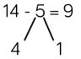  14 – 4 = 10  10 - 1 = 9
Stage 5:  Column method  TO – O  (48-7=41) | Children will use base-ten equipment and place value grids by physically removing the correct number of ones.  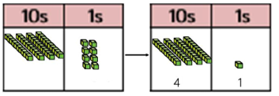 | Children will then move onto representing the base-ten pictorially.  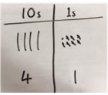 | Children will then make links between the pictorial representation and the column method.  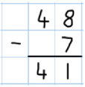
Stage 6: Column method involving an exchange.  TO – TO  (41-26=15) | Children will begin to explore the concept of making an exchange by using base-ten equipment. (This can also be shown with place value counters). They will realise that they cannot subtract 6 from 1 so will need to exchange 1-ten rod for 10 lots of one-cubes.  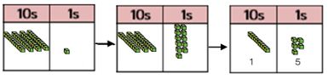 | The children will move onto representing the base-ten equipment pictorially. They will show the exchange with circles and an arrow. Subtraction will then be shown by crossing out.  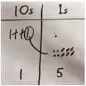 | The children will then progress to using the formal method of subtraction. Exchanges will be shown by crossing out and rewriting.  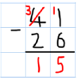  It is important for the children to make the connection that 41 = 30+11 therefore they have not changed the original value.
Stage 7:  Column method involving two or more exchanges.  HTO-TO  (234-88=146) | 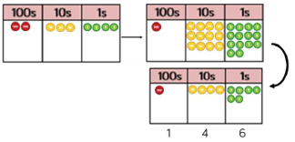  Children will base-ten equipment or place value counters to represent the exchanges that need to be made. They are then able to remove the relevant counters to reach an answer. | Children will move onto representing the counters pictorially. They must remember to show their exchanges.  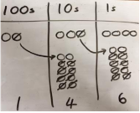 | Children will make links to the formal column method where exchanges are crossed out and rewritten.  (Second exchange is shown in red)  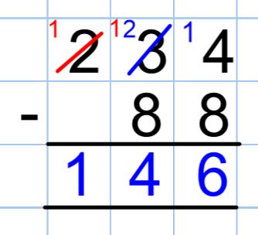

Calculation policy: Multiplication

Key language: double, times, multiplied by, the product of, groups of, lots of, equal groups.
 | Concrete | Pictorial | Abstract
Stage 1: Repeated grouping/ repeated addition  (3x4=12) | The children will begin by grouping objects into equal groups and make the connection to repeated addition.  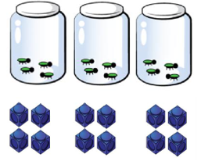  This shows that there are 3 equal groups with 4 objects in each group. | Children will represent the practical resources into pictorial representations, including the bar model.  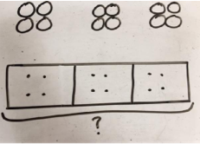 | Children will write repeated addition calculations as simple multiplication statements.  4 + 4 + 4 = 12  3 X 4 = 12
Stage 2: Multiplying by repeated groups  (3x4=12) | Children will use resources such as Numicon, Cuisenaire rods or a ruler to show that multiplication is counting up in groups.  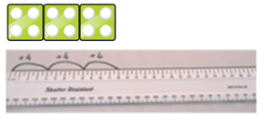 | This will then be drawn pictorially incorporating a number line.  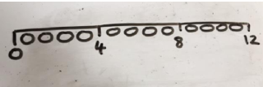 | Children will use an empty number line to work out and record their answer.  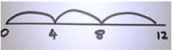
Stage 3: Using an array to illustrate commutativity  (2x5=5x2) | Children will investigate this rule with counters, cubes and other mathematical resources.  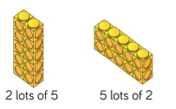 | Children will then progress to representing their arrays pictorially.  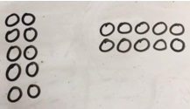 | Children will draw upon their knowledge of arrays to write a range of equivalent calculations.  10 = 2 X 5  5 X 2 = 10  2 + 2 + 2 + 2 + 2 = 10  10 = 5+ 5
Stage 4: Using partitioning to multiply.  (4x15=60) | 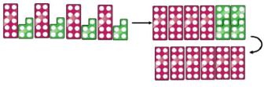  Children will begin by using resources such as Numicon or base 10 to multiply a two-digit number by partitioning it. | They will then be introduced into ways of representing this pictorially. They will be shown how to represent any ‘exchanges’ by grouping them together.  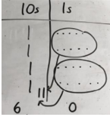 | Children will then be shown ways of recording the same steps using numbers.  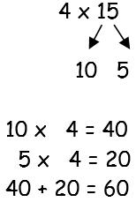  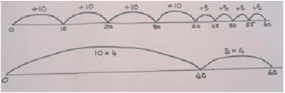  A number line can also be used to show this concept.
Stage 5: Formal column method without carries/ exchanging. (3x23=69) | The children will begin by using mathematical equipment such as place value counters or base 10 to show groups of larger numbers.  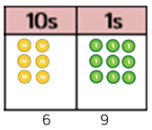 | Children will be shown how to represent the counters pictorially.  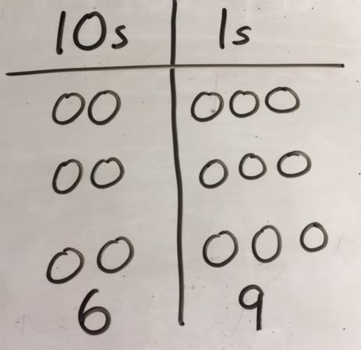 | Children will be introduced to several ways of recording their answers, culminating in the formal written method.  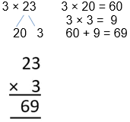
Stage 6: Formal column method with carries/ exchanging. (6x23=138) | The children will begin by using place value counters or base 10 resources to investigate what happens when multiplication of larger digits result in having to make an exchange.  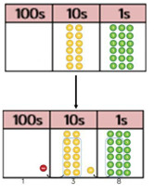 | Children will then represent the place value counters/base 10 equipment pictorially.  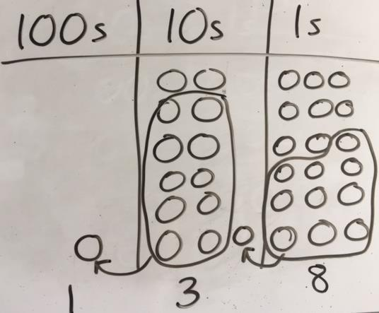 | When their understanding of place value is concrete, they will begin to show these calculations using the formal written method.  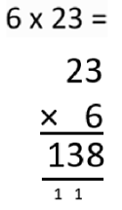
Stage 7: Formal method of larger numbers starting with TOxTO. | Children will be moved to this only when they are confident with using the abstract of the above method. |  | 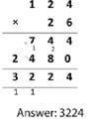

Calculation policy: Division
Key language: share, group, divide, divided by, half.
 | Concrete | Pictorial | Abstract
Stage 1: Sharing  (6÷2=3) | Children will be introduced to the concept of sharing by placing objects into equal groups.  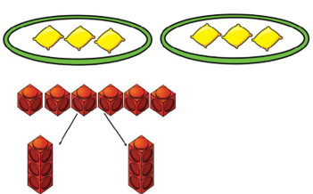 | The children will then represent this pictorially.  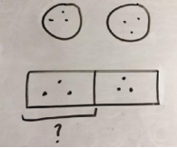 | They will then be encouraged to call upon their times tables knowledge to solve simple division. A bar model may be used to represent this with numbers.
Stage 2: Repeated subtraction  (6÷2=3) | Children will be introduced to this concept by using concrete resources such as Cuisenaire rods above a ruler.  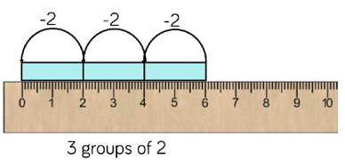 | Children will represent subtraction pictorially.  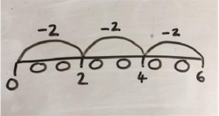 | Children will then progress to using an empty number line to represent equal groups that have been subtracted.  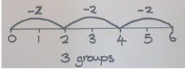
Stage 3: TO ÷0 with remainders  (13÷4=3r1) | Children will use concrete resources such as lolly sticks or Cuisenaire rods to demonstrate the concept of remainders (leftovers).  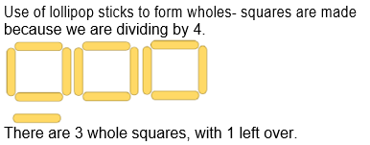 | 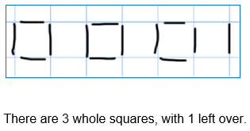  Children will then progress onto representing the lolly sticks pictorially. | Children are encouraged to use their times table facts to work out near multiples.  13 ÷ 4 = 3 r 1  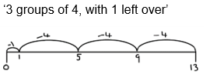  They could also represent this as repeated addition on a number line.
Stage 4: Exchanging in division  (42÷3=14) | Children will use place value counters or base 10 equipment to partitioning larger numbers when dividing. They will use their understanding of exchanging when a calculation cannot be performed in that particular place value column. E.g. the spare ten-counter will be exchanged for 10 lots of ones-counters to make 12.  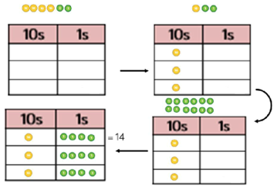 | Children will then represent the place value counters pictorially.  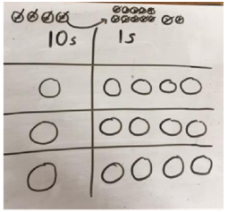 | Children will be able to write down the steps they are taking in a logical order.  42 ÷ 3  42 = 30 + 12  30 ÷ 3 = 10  12 ÷ 3 = 4  10 + 4 = 14
Stage 5: Short division formal method  615÷5=123 | Children will initially use place value counters to perform these divisions and track what is happening to the exchanges.  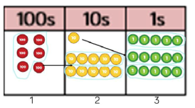  - Make 615 with place value counters.  - How many groups of 5-hundreds can you make with 6 hundred counters? (1)  - Exchange the 1 remaining hundred-counter for 10 lots of tens-counters.  - How many groups of 5 tens can you make with 11 tens-counters? (2)  - Exchange the 1 remaining tens-counter for 10 lots of ones-counters.  - How many groups of 5 ones can you make from 15 ones-counters? (3) | Children will then represent this pictorially.  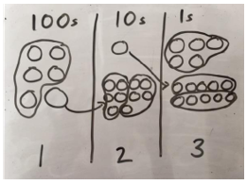 | Children will then progress onto using the formal method for short division (bus stop method).  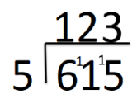
Stage 6: Long division formal method  (2544÷12=212 | Children will only be progressed onto this method if they are confident with the above abstract formal method and have a concrete understanding of place value. They will use place value counters alongside the formal written method so that comparisons can be seen and understood.  