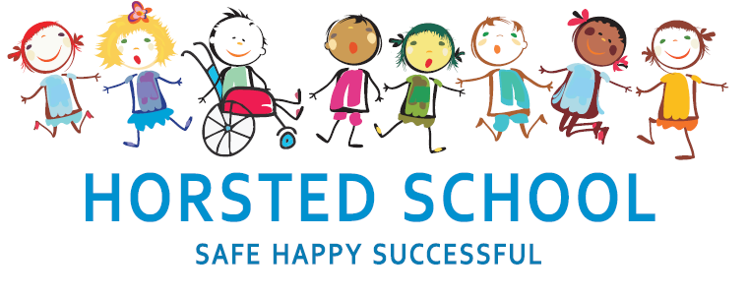
ENGLISH POLICY

Horsted school is a vibrant, safe and welcoming school where we celebrate and welcome differences within our school community. The ability to learn is underpinned by the teaching of basic skills, knowledge, concepts and values with a vision to prepare pupils for a happy and healthy life beyond primary school.
Our vision for Horsted School is that our children will leave us with a genuine enthusiasm for learning and as
- Striving (they will be determined, persevere and they will be resilient);
- Thoughtful (They will be creative, logical and curious about their world and those around them);
- Aspirational (personally, emotionally and academically);
- Respectful (of themselves, others and their environment) and;
- Supportive (of themselves, others and their wider community) individuals.

Aim and purpose
We aim to achieve this through our curriculum’s rich web and in partnership with parents. The curriculum at Horsted is designed to provide an enjoyable, broad and balanced education that meets the needs of all children. It provides opportunities for children to develop as independent, confident and successful learners, with high aspirations, who know how to make a positive contribution to their community and the wider society.
Horsted is an inclusive school. We strive to ensure that all children will be able to access the curriculum or make necessary modifications to it in order to achieve this.

Review date | March 2020
Reviewed by | Laura Packman
Next Review | March 2023

Approved by

Headteacher: ______________________________________ Date: ___________________

Chair of Governors: _________________________________ Date: ___________________

ENGLISH POLICY

The National Curriculum (2014) clearly states that teaching the English language is an essential, if not the most essential role of a primary school. Our duty is to ensure that the teaching of English is prioritised and taught across the whole curriculum to enable children to excel throughout school life and beyond. It is part of the ‘essential knowledge’ (p6 National Curriculum) that is needed in society:
‘Teachers should develop pupils’ spoken language, reading, writing and vocabulary as integral aspects of the teaching of every subject. English is both a subject in its own right and the medium for teaching; for pupils, understanding the language provides access to the whole curriculum. Fluency in the English language is an essential foundation for success in all subjects.’ (P10 National Curriculum)’

Aims and Purposes

At Horsted, our intention is to ensure that children leave primary school with the ability to:
∙ read easily, fluently and with good understanding
∙ develop the habit of reading widely and often, for both pleasure and information
∙ acquire a wide vocabulary, an understanding of grammar and knowledge of linguistic conventions for reading, writing and spoken language
∙ appreciate our rich and varied literary heritage
∙ write clearly, accurately and coherently, adapting their language and style in and for a range of contexts, purposes and audiences
∙ use discussion in order to learn; they should be able to elaborate and explain clearly their understanding and ideas

STARS
Learning English encourages pupils to become STARS.
Striving - Children will be encouraged to learn from mistakes that they make, realising that they are part of the learning process and nothing to feel ashamed by. They will revisit work and edit writing encouraging their perseverance and resilience.
Thoughtful - Children will access a range of different texts in their time at Horsted which they will discuss with their peers in a thoughtful manner. They will discuss and write about preferences and justify their opinions. As part of learning English, children will learn about grammar which they will have to be thoughtful in their application.
Aspirational - Children aim to achieve. They are encouraged to make aspirational progress - moving through different colour banded reading stages and ‘publishing’ their written work for example. Children are encouraged to use their English learning within all other subject areas.
Respectful - Developing opinions is important and so is being respectful when listening and discussing them with others. Children also share work with partners when peer assessing which encourages children to give constructive feedback.
Supportive - Children will work in groups when learning English. They will learn to work well with one another. Additionally, activities such as drama will encourage children to work together and present to the class who will be supportive of their peers.

Organisation of the English Curriculum

We follow the English Programme of Study as laid out in the National Curriculum for English (Key Stages 1&2) 2014 and the Statutory Framework for the early years foundation stage 2021.
EYFS practice continues to build on the language experiences from home ensuring that they develop a language rich environment with frequent access to stories and well modelled conversations. They also begin laying the foundations of children learning to read and write through their daily read, write inc sessions.
Children in KS1 (and those who continue to need it in LKS2), continue with the read, write inc programme. An appropriate balance of word, sentence and text level work, and a high level of direct and interactive teaching are maintained. Opportunities for children to practice and develop their English skills are planned into the foundation curriculum subjects alongside a planned cross-curricular approach to reading and writing across the curriculum.

Reading

At Horsted, we are committed to teaching our pupils to become skilled readers who develop a comprehensive understanding of words, language and texts as they move through school. They learn to read and then read to learn. Our aim is to ensure that pupils develop a love of reading so that they can read for purpose and for pleasure. We provide children with a range of reading opportunities in order to do this:

EYFS | Year 1 | Year 2 | Year 3 | Year 4 | Year 5 | Year 6
Phonics Read, Write Inc (daily) |  |  | RWI if needed | Fresh start if needed
Daily class text to read for pleasure.
Individual Reading books
 |  |  | Whole Class Reading Sessions with a focus on comprehension (weekly)
Whole Class Text which drives the English Curriculum (daily)
This is completed with children once they have finished the Read, Write Inc programme of study.
Library visits (weekly in school, monthly library bus)

It is our intention to ensure that, by the end of their primary education, all pupils at Horsted School are able to read fluently, and with confidence, in any subject in their forthcoming secondary education.
There are three components to fluency, which we explicitly teach and model in reading sessions:
Accuracy involves reading words correctly. Those who read with automaticity recognise words automatically, without having to decode or process them.
Proficiency in accuracy and automaticity leads to an increased reading rate, but speed alone does not encompass fluency in its entirety.
A third factor of fluency is prosody. Prosodic reading includes the use of intonation, phrasing, pausing and expression while reading. When reading orally, prosody provides a clue to the reader’s comprehension of a text.

Phonics

Phonics is prioritised in the teaching of early reading. We aim to provide high quality, systematic phonic work taught discretely in EYFS and KS1 for a minimum of 20 minutes per day. We believe that phonics sessions should be engaging, interactive and delivered at a quick pace. Read, Write Inc is used as the spine for delivery of the phonics sessions as part of the children’s ‘speedy sound’ sessions. Read Write Inc mnemonics are used in KS1 to support phonic sessions.
Phonics is taught by teachers and teaching assistants in EYFS and KS1 to small groups of children organised by ability groups. They learn the relevant GPCs, blending and segmenting skills and spelling rules by each phase to ensure that learning is progressive and teaching effective.
In EYFS and Key Stage 1, written phonics work is completed on whiteboards and in 'Phonic Books' during phonics sessions. This may include letter formation and practice, word segmenting or sentence writing.
Teachers assess children's phonetic development continually but specifically at the end of each phase to ensure that errors, misconceptions and gaps in learning are quickly identified and addressed.
For children who have not met the Key Stage 1 phonics screener at the end of Year 1, or who still require phonics input in KS2, booster sessions and intervention groups are delivered in a similar fashion to Key Stage 1 to ensure that children learn the phonics skills required.

Individual reading

The school uses a variety of books from a wide range of scheme and non-scheme publications. In EYFS and Key Stage 1 books are banded into phonic phases and teachers choose specific books for children to take home and read. Additionally, children are allowed to take an aspirational book home from the school library that their parents will read with them.
In Key Stage 2, children have access to a range of colour banded reading books and are allowed to choose books themselves, from the appropriate colour band in the library. Colour banded reading scheme books are supplemented with other texts which are assessed before banding. These books are taken from a range of genres, topical content and classic literature and therefore, provide a solid grounding from which to explore further different authors and text types.
Across the whole school, children read aloud to an adult regularly. When children have sufficient skills to decode a school reading book, books are sent home and changed twice per week or as required depending on the length of the book.
Children read to a teacher or teaching assistant on a one-to-one basis at least once a week (or every other week in Upper Key Stage 2). Children who are making slow progress with their reading will have appropriate intervention put in place and will read one to one more regularly.

Whole Class Reading Comprehension

Once the children have completed their Read, Write, inc program of learning, children have at least a once weekly whole class reading session, with the aim of developing specific reading skills. We use these sessions to encourage all pupils to read widely across both fiction and non-fiction and develop their comprehension skills.
At Horsted we use child-friendly symbols and acronyms to encourage the children to remember key reading skills. These are regularly revisited and consolidated in English and other curriculum areas.

Reading for Pleasure

At Horsted, we not only teach children how to read, we intend to nurture a love of reading.
In order to facilitate this, the teaching of reading is also embedded in the wider curriculum, giving children the opportunity to transfer and apply their reading skills in other subjects.
Once the children have completed their Read, Write, inc program of learning, our English lessons are based on core texts that will inspire and engage our children and help drive our English Curriculum; although most of these books remain the same from year to year, we take into consideration the children’s interests or current affairs and sometimes the main driving text changes as a result. Where possible, we link the driving text to the ‘topic’ that the children are learning.
Children are read to by members of staff regularly throughout the week; texts are chosen to inspire pupils and are based on their interests.

Library

Our school aims to develop and foster a love of reading as well as encourage independence. The role of the school library is central in supporting our children’s learning, as it plays a key role in helping them develop their communication, information handling and research skills. Each class visits the library once a week as a class and Key Stage 2 children are allowed to change their books independently.
All children are signed up to Medway libraries on their entry to the school. The local library bus visits the school once per term and children are able to borrow books to take home.

Parental Involvement

The school actively encourages parents to read with their children. Strategies to support reading at home are shared with parents in EYFS. In EYFS and KS1, parents are asked to listen to their child read at home at least three times a week. Communication regarding reading is shared between parents and teachers via ‘Reading Records’ in the children’s reading diaries.

In KS2, children are required to read for 20 minutes, at least three times per week independently and with or to an adult. The children record their own reading in homework diaries. Parents and teachers are asked to check and sign homework diaries on a weekly basis.

Writing

At Horsted, the link between the teaching of reading and writing should be seamless. Teachers plan learning through the ‘whole book’ approach. This means that one specific and carefully chosen key text/novel both stimulates and drives the learning across a unit of work.

Writing at length
Drawing on their understanding of the core text, children are taught to write at length and with stamina. They write for a range of purposes and audiences applying their grammar, punctuation and spelling to the different contexts.
Once writing has been drafted, children edit to make corrections and improvements. Editing may be completed independently or with adult support. Once children have edited their work, they will ‘publish’ their work.

Grammar, Punctuation and Spelling
Throughout school, grammar and punctuation strategies are taught explicitly to the children both in and out of context. All children are supported to write with increasing accuracy, using standard English. We achieve this by first examining how authors employ such features and then support children to practise, apply and embed those skills in their own writing. Each year group’s outcomes are clearly identified in line with the National Curriculum and consolidate skills taught in previous years and introduce the new year group’s expected outcomes.
Teachers model expected writing using key skills which will be specifically taught in each year group. At Horsted, we use the Nelson Thornes Spelling programme to introduce the different spelling patterns and form the main spine of spelling teaching: this is supplemented with a wide range of other activities and resources to embed. Children are set tasks weekly and teachers monitor this regularly. Any children who are struggling with a particular area of spelling, have their own word lists set to consolidate or learn.

Handwriting

Here at Horsted School we are very proud of our pupils’ handwriting and take particular care in our cursive/joined-up handwriting style. We use Collins: Treasure House Handwriting that covers all the requirements of the 2014 National Curriculum. Handwriting is a basic skill that influences the quality of work throughout the curriculum. At the end of Key Stage 2, all pupils should have the ability to produce fluent, legible and, eventually, speedy joined-up handwriting. They should understand that different forms of handwriting can be used for different purposes. We aim to make handwriting an automatic process that does not interfere with creative and mental thinking. As a catalyst to speedy handwriting we encourage parents and carers to support handwriting practice at home.
School aims:
We aim for our pupils to develop a neat, legible, speedy handwriting style that uses continuous cursive letters.
By the end of year 6, pupils will understand the importance of neat presentation and the need for different letterforms (cursive, printed or capital letters) to help communicate meaning clearly.
Method:
Our teachers are encouraged to use neat, joined-up cursive writing for all handwriting tasks including displays, marking and comments.
To aid pupils’ understanding, they will experience coherence and continuity in the learning and teaching of handwriting across all school years and be encouraged to take pride in the presentation of their work. Our aim is to help pupils enjoy learning and developing their handwriting with a sense of achievement and pride.
Letter formation:
As recommended by the British Dyslexia Association, we adopt a continuous cursive style of writing.
Teachers and Learning Support Assistants model the agreed cursive style when modelling writing both in class, on displays and in feedback in books.
Our agreed cursive style is as below:
Capital letters:
ABCDEFGHIJKLMNOPQRSTUVWXYZ
Un-joined cursive:
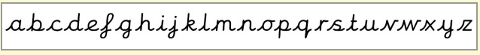
Joined cursive:
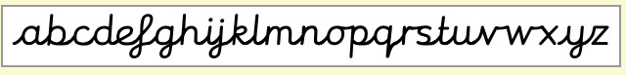
Numbers:
0123456789

Letters and their correct formation are taught in ‘families’. The letters in each of the ‘families’ are formed in a similar way allowing children to apply letter formation skills from one letter to another within the same ‘family’.
The families are:
‘Ladder letters’ – l, i, t, j, y, u
‘One armed robot letters’ – r, b, n, h, m, k, p
‘Curly Caterpillar letters’ – c, a, o, d, g, q, e, s, f
‘Zig Zag monster letters – v, w, x, z

Handwriting frequency:
Handwriting is a cross-curricular task and will be taken into consideration during all lessons. Formal teaching of handwriting is to be carried out regularly and systematically to ensure Key Stage targets are met.
FOUNDATION:
Children will be introduced to pre-cursive and cursive script at the earliest stages of writing. Children in the Foundation Stage should be writing in pre-cursive script in terms 5 and 6 to enable an easier transition in Year 1 into the joined cursive script, depending on their ability. Activities that develop children’s motor-function skills (both gross and fine) are embedded into normal classroom practice on a daily basis. However, we aim for a daily session that focuses on handwriting skills totalling to at least 50 minutes a week. Sessions will include:
- movements to enhance gross motor skills such as air-writing, pattern making and dancing;
- exercises to develop fine motor skills such as making marks on paper, whiteboards, blackboards, and sand trays; and
- letter learning to familiarise letter shapes, formation and vocabulary.
YEARS 1 TO 2:
Children will move from a pre-cursive font to a joined cursive font. The decision of when to move individual children to a joined font will the class teacher’s responsibility. Tuition will continue with two to three weekly sessions totalling 30 to 45 minutes covering:
- gross and fine motor skills exercises;
- cursive handwriting reinforcement, learning and practice.
- numerals, capitals and printed letter: where and when to use, learning and practice.

YEARS 3 to 6:
More advanced handwriting techniques will be taught during two to three weekly sessions totalling 30 to 45 minutes teaching:
- cursive handwriting re-enforcement;
- form-filling/labelling using printed; and
- dictation exercises to teach the need for quick notes and speedy handwriting.

Key Stage Teaching:
EYFS:
- Sit in the correct position and hold a pencil correctly to allow fluid movement of the nib.
- Improve fine and gross motor skills by drawing pre-cursive patterns in a variety of writing materials such as modelling clay, air writing, sand trays, felt pens, crayons, pencils, IWB, iPads/tablets.
- Understand the language needed to describe pencil movements in preparation of letter formation.
- Hold a pencil in a correct manner for writing and be encouraged to correct any errors in grip or stature.
- Understand that letters are written on a base line and that all cursive letters ‘start on the line’ and ‘end with a hook’.
- Begin to form some recognisable joined-up cursive letters, capital letters and numerals.
- Have an understanding of writing their own name.
- Understanding different shaped letter families.
KEY STAGE 1:
  - Write legibly using upper and lower case letters with correct joins.
  - Ensure that letters sit on the base line and are consistent in size with ascenders and descenders that are the correct length and formation.
  - Leave the correct space between words.
  - Form capital letters and use where appropriate.
  - Form numerals that are consistent in size and sit on the base line.
  - Improve the speed of writing and begin to write automatically so promoting creativity in independent writing.
KEY STAGE 2:
Improve quality, speed and stamina of handwriting.
  - Quality: Ensure letters are consistently sized with equal word spacing and that ascenders and descenders are parallel and do not touch words on the lines above and below.
  - Speed: Improve speed of handwriting to allow creative writing to take precedence over the task of handwriting and be able to take ‘quick notes’ at a faster pace.
  - Stamina: Have the strength and mobility to be able to write for longer periods of time without fatigue.
Have full knowledge and ability of the different forms of handwriting for different purposes:
  - Neat, joined, cursive letters for writing passages and large amounts of text, lists and letters.
  - Printed or capital letters for posters, notices, headings, labelling, and form filling.
  - Speedy handwriting for note-taking and dictation where neatness is not as important and shortcuts, such as + instead of ‘and’, can be used.

Correct posture and pencil grip for handwriting:
Pupils should be taught to sit correctly at a table, holding a pencil comfortably and correctly.
Both right and left handed children should be encouraged to use the tripod grip which allows the pen/pencil to be held securely whilst allowing controlled movements of the pen/pencil nib.
- Grip the pencil with your index finger and thumb with the nib pointing away.
- With your free hand, spin the pencil from underneath.
- Use your middle finger to support the underside of the pencil.
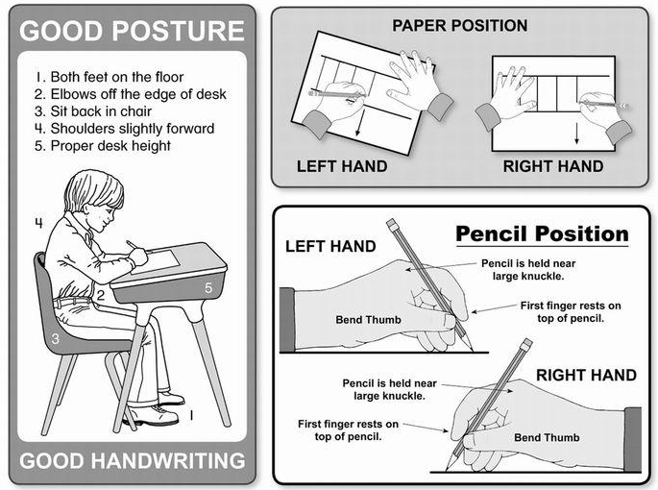
Left-handed children:
Left-handed children may find it difficult to follow right-handed teachers as they demonstrate letter formation (and vice versa). Teachers should demonstrate to left-handers on an individual or group basis.
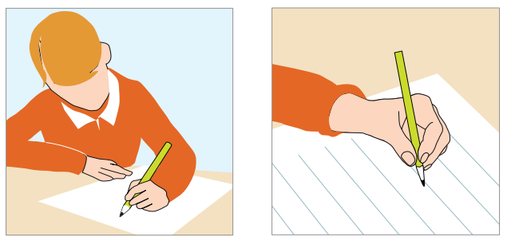
- Left-handed pupils should sit to the left of a right-handed pupil so that they are not competing for space.
- Pupils should position their paper/book to their left side and slanted, as shown above.
- Pencils should not be held too close to the point as this can interrupt pupils’ line of vision.
- Extra practice with left-to-right exercises may be necessary before pupils write left-to-write automatically.
Ball-point pens may be used by some left-handed pupils if there is an issue with smudging when they write with a handwriting pen. This decision is at the discretion of the child’s class teacher.
Inclusion:
Children whose handwriting is limited by problems with fine motor skills, including left-handed children, and children with special educational need, may require additional support to help them meet their full potential. This support may come in a range of different formats, including:
- additional activities that promote the development of fine and gross motor function skills;
- one-to-one support led by a teacher or TA;
- small group support lead by a teacher or a TA;
- different writing equipment may be given such as a pencil grip or a curved pen; and
- different equipment to help writing posture may be given such as a sloped desk or seated posture support.
Even with support, some children may not progress as is expected with handwriting. They may have specific learning needs relating to fine motor function skills. If this is the case, the child’s teacher, in discussion with the SENCO, Literacy co-ordinator and the child’s parents, may choose to adopt a pre-cursive handwriting style.

Pens and pencils:
Children will begin handwriting using a soft pencil. When children have developed a fluent style of handwriting, they will be permitted to use a handwriting pen that the school will buy. At this point, the child will be given a pen licence.
It is very important that writing equipment is weighted appropriately to promote the best handwriting possible. Children should not put toys or pencil ends on the end of their writing equipment as this negatively affects the quality of handwriting. Teachers and TAs will ask children to remove them.
A pencil is always used in maths regardless of whether a child has a pen licence.

Spoken Language

We intend for our pupils to speak clearly and confidently in order to articulate their views and opinions. We teach children to express themselves orally in an appropriate way, matching their style and response to audience and purpose, listening and responding to literature, giving and receiving instructions. Children develop the skills of participating effectively in group discussions.
From Reception to Year 6, all children are encouraged to:
∙ Justify ideas with reasons.
∙ Ask questions to check understanding.
∙ Develop vocabulary and build knowledge.
∙ Negotiate.
∙ Evaluate and build on the ideas of others.
∙ Select the appropriate register for effective communication.
∙ Give well-structured descriptions and explanations.
∙ Speculate, hypothesise and explore ideas.
∙ Organise their ideas prior to writing.

Assessment, recording and reporting
Teachers assess children’s work in English work in three phases. The short-term assessments that teachers make as part of every lesson help them to adjust their daily plans. They match these short-term assessments closely to the teaching objectives. Written or verbal feedback is given to help guide children’s progress. Children are encouraged to make judgements about how they can improve their own work especially through the editing process.
Teachers use medium-term assessments to measure progress against the key objectives, and to help them plan for the next unit of work.
Teachers make long-term assessments towards the end of the school year, and they use these to assess progress against school and national targets. With the help of these long-term assessments, they are able to set targets for the next school year, and to summarise the progress of each child before discussing it with the child’s parents or carers. The next teacher then uses these long-term assessments as the planning basis for the new school year.
These long-term assessments are based on ongoing tests and teacher assessments. Children undertake the national tests at the end of Year 2 and Year 6, and ongoing tests, sat twice throughout the academic year, are used with all year groups as the school year progresses. Teachers also make annual assessments of children’s progress against the age related expectations as outlined in the National Curriculum and the teacher assessment framework.

Homework

Homework in English will be set in line with the school policy. There is a clear expectation that all children will spend time reading / sharing books at home on a regular basis - see reading section of this policy. From Year One to Year 6, children are given spellings patterns or rules to learn. They may also receive sets of high frequency words to revise. These will be individual to the children. Spelling tests will take place using similar patterns and rules.

Links with other subjects

Pupils should be taught in all subjects to express themselves correctly and appropriately and to read accurately and with understanding. At Horsted, we truly value the importance of using high quality texts across the curriculum. Speaking and listening, reading and writing are embedded into cross curricular and theme planning. Since Standard English, spoken and written, is the predominate language in which knowledge and skills are taught and learned, pupils should be taught to recognise and use Standard English. Pupils should be taught the technical and specialist vocabulary of subjects and how to use and spell these words. They should also be taught to use the patterns of language vital to understanding and expression in different subjects.

