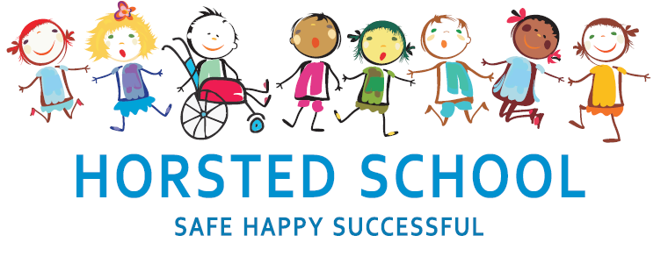
SCIENCE POLICY

Horsted school is a vibrant, safe and welcoming school where we celebrate and welcome differences within our school community. The ability to learn is underpinned by the teaching of basic skills, knowledge, concepts and values with a vision to prepare pupils for a happy and healthy life beyond primary school.
Our vision for Horsted School is that our children will leave us with a genuine enthusiasm for learning and as
- Striving (they will be determined, persevere and they will be resilient);
- Thoughtful (They will be creative, logical and curious about their world and those around them);
- Aspirational (personally, emotionally and academically);
- Respectful (of themselves, others and their environment) and;
- Supportive (of themselves, others and their wider community) individuals.

Aim and purpose
We aim to achieve this through our curriculum’s rich web and in partnership with parents. The curriculum at Horsted is designed to provide an enjoyable, broad and balanced education that meets the needs of all children. It provides opportunities for children to develop as independent, confident and successful learners, with high aspirations, who know how to make a positive contribution to their community and the wider society.
Horsted is an inclusive school. We strive to ensure that all children will be able to access the curriculum or make necessary modifications to it in order to achieve this.

Review date | March 2020
Reviewed by | Laura Packman
Next Review | March 2023

Approved by

Headteacher: ______________________________________ Date: ___________________

Chair of Governors: _________________________________ Date: ___________________
SCIENCE POLICY

“A high-quality science education provides the foundations for understanding the world through the specific disciplines of biology, chemistry and physics. Science has changed our lives and is vital to the world’s future prosperity, and all pupils should be taught essential aspects of the knowledge, methods, processes and uses of science. Through building up a body of key foundational knowledge and concepts, pupils should be encouraged to recognise the power of rational explanation and develop a sense of excitement and curiosity about natural phenomena. They should be encouraged to understand how science can be used to explain what is occurring, predict how things will behave, and analyse causes.”
(The 2014 Primary National Curriculum in England, Science, page 144)

Aims:

The National Curriculum for science aims to ensure that all pupils:
- develop scientific knowledge and conceptual understanding through the specific disciplines of biology, chemistry and physics
- develop understanding of the nature, processes and methods of science through different types of science enquiries that help them to answer scientific questions about the world around them
- are equipped with the scientific knowledge required to understand the uses and implications of science, today and for the future.
(The 2014 Primary National Curriculum in England, Science, page 144)

Expectations:

By the end of each key stage, pupils are expected to know, apply and understand the matters, skills and processes specified in the relevant programme of study. (DfE 2014)

Organisation and Planning:

All children from years 1 to 6 will be taught a dedicated Science lesson on a weekly basis. Children in Reception will cover the Science objectives in the EYFS curriculum through a range of planned and child led learning opportunities.

Planning is completed as a shared process between the teachers in each group. It is each teacher’s responsibility to ensure that all objectives and working-scientifically skills are being taught both thoroughly and regularly as part of their good practice and quality first teaching and learning over time. To help ensure coverage, teachers use a range of published schemes of learning, drawing out and picking the activities that they believe will best support the learning of their class. Teachers draw upon high quality, purpose-specific resources by Rising Stars, Twinkl and The Hamilton Trust, amongst others, ensuring full coverage of the National Curriculum. Children learn how to think scientifically and draw on the full range of ‘working scientifically’ methods throughout their time in each year group in a progressive manner. Each planning unit must include, where appropriate and possible, the completion of a full investigation.

Assessment, recording and reporting:

Each child’s performance in Science will be assessed by the teacher using ongoing formative assessment. Formative assessment is ongoing assessment used to monitor student learning in order to provide feedback that can be used to improve teaching and learning outcomes. Teachers record learning outcomes in a termly assessment book and summative assessments are recorded. Summative assessments indicate if the teacher thinks the child is working towards the expected level, at the expected level or at greater depth.

We check pupils’ understanding systematically and effectively in lessons, offering clearly directed and timely support, i.e. moving children on from their starting points, providing different starting points and addressing misconceptions at the point of need. We provide children with incisive verbal feedback, about what they can do to improve their knowledge, understanding and skills.

Links with other subjects:

The Working Scientifically strand of the National Curriculum allows for links to be made with other Curriculum subjects, particularly Mathematics and Design Technology. Other subject specific knowledge objectives allow links to be made with other subjects such as Geography and PE. This list Is not exhaustive and other links may be made throughout the curriculum. Links should be made across all subjects where appropriate in line with our curriculum. Science, in KS1 tends to be taught in a more thematic manner linking to topics whilst in KS2, science tends to be taught more discretely (outside of topic) with links made when they are meaningful.

Inclusion and differentiation:

In order to provide all pupils with relevant and appropriate work at each stage, we:
- Assess prior learning to set suitable learning challenges
- Respond to pupils’ diverse needs, this could include, but is not limited to, giving a context to help a pupil anchor their knowledge, breaking down the learning process, adapting methods and ways to record results
- Endeavour to overcome potential barriers to learning

The Role of the Subject Leader:

- To advise colleagues, where necessary, on the development of planning and delivering the curriculum.
- To keep up to date with developments in design and technology education passing this on to other members of staff.
- To monitor and evaluate progress and outcomes in design and technology, supported by the progression document for Science and liaise with senior leadership on any action necessary.
- To liaise with appropriate bodies e.g. other primary and secondary schools, governors, the LEA etc. concerning matters relating to design and technology.
- To monitor learning in design and technology by working alongside colleagues and by viewing children's achievements.

Resources:

Science resources are kept in the Science cupboard by the KS2 hall. These are shared resources for the whole school. Any requests for new resources should be passed to the science subject leader.

Health and safety:

When working with tools, equipment and materials, in practical activities and in different environments, including those that are unfamiliar, pupils should be taught:
- about hazards, risks and risk control.
- to recognise hazards, assess consequent risks and take steps
- to control the risks to themselves and others.
- to use the information to assess the immediate and cumulative risks.
- to manage the environment to ensure the health and safety of themselves and others.
- to explain the steps they take to control risks.

Teachers will include in their medium/short term planning, a risk assessment outlining tools and materials which could pose a possible risk to pupils/staff using them.

