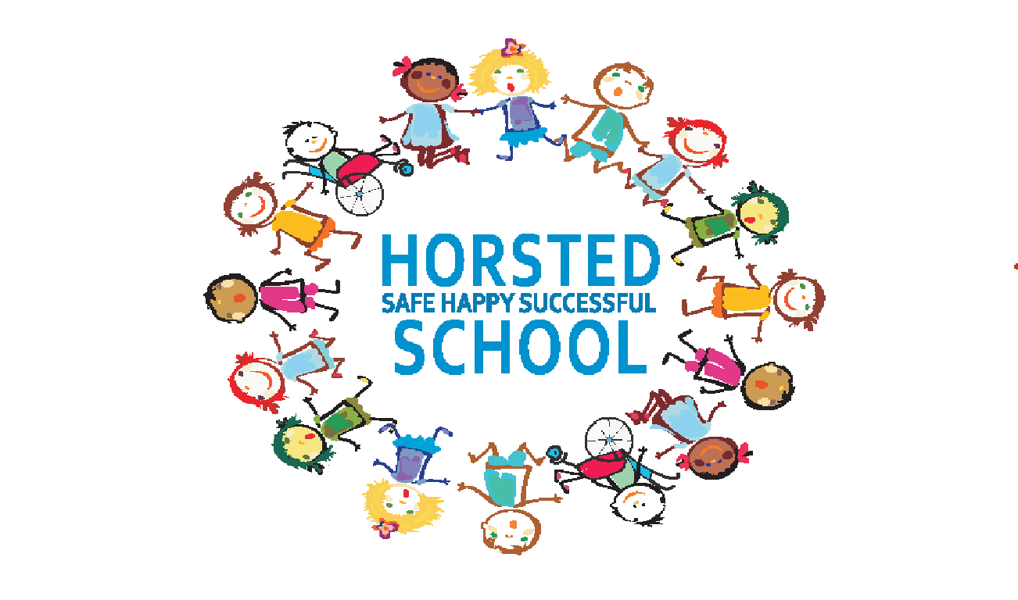

HORSTED SCHOOL
EARLY YEARS FOUNDATION STAGE POLICY

At Horsted school there are four guiding principles from the EYFS Curriculum which shape our practice.
These are:
- Every child is a unique child, who is constantly learning and can be resilient, capable, confident, and self-assured.
- Children learn to be strong and independent through positive relationships.
- Children learn and develop well in enabling environments with teaching and support from adults, who respond to their individual interests and needs and help them to build their learning over time. Children benefit from a strong partnership between practitioners and parents and/or carers.
- Children develop and learn at different rates. The framework covers the education and care of all children in early years provision, including children with special educational needs and disabilities (SEND).

The Curriculum
Our curriculum encompasses seven areas of learning and development. All areas of learning and development are important and inter-connected.
Three areas are particularly important for building a foundation for igniting children’s curiosity and enthusiasm for learning, forming relationships, and thriving.
These are called the prime areas:
• communication and language
• physical development
• personal, social, and emotional development.
Four areas help children to strengthen and apply the prime areas.
These are called the specific areas:
• literacy
• mathematics
- understanding the world
• expressive arts and design
Throughout their time in the Reception Year our children partake in an ambitious curriculum which is designed in a sequential way to ensure progress towards the end of reception goals. These goals are defined as Early Learning Goals (ELGs)

Characteristics of Effective Learning
Weaving throughout the EYFS curriculum at Horsted are three Characteristics of Effective Learning.
- playing and exploring - children investigate and experience things, and ‘have a go’
- active learning - children concentrate and keep on trying if they encounter difficulties, and enjoy achievements
- creating and thinking critically - children have and develop their own ideas, make links between ideas, and develop strategies for doing things
These elements underpin how we reflect on each child’s development and adjust our practice accordingly. Supporting children in their individual learning behaviour and observing the context of children’s play is essential.
Teaching strategies
We ensure there is a balance of adult led and child initiated activities across the day. Although
much of the time is spent with children self-selecting tasks, the interaction between the adult and child is essential as the adult’s response to children builds understanding and therefore guides new learning. The adult’s role is to continually model, demonstrate and question what the child is doing.
In some cases the adult will ask a child to come and complete a task or game with them; at other
times they will participate in a child’s game, extending it where possible.
By the Summer terms in Reception the children will begin their transition into year one.

Play
Learning through play is an important part of our Early Years classrooms. We believe children learn best from activities and experiences that interest and inspire them. Using children’s interests as a starting point, we provide children with stimulating, active play experiences in which they can explore and develop their learning to help them make sense of the world. They have opportunities through their play to think creatively and critically alongside other children as well as on their own.
They are able to practise skills, build upon and revisit prior learning and experience at their own
level and pace. Play gives our children the opportunity to pursue their own interests and inspire
those around them. The children learn to adapt, negotiate, communicate, discuss, investigate and ask questions. We believe it is important that adults take an active role in child initiated play through observing, modelling, facilitating and extending their play. Getting the balance right between child initiated play, which is controlled, and adult led activities is very important to us.

Teaching
We include direct, carefully planned, adult led experiences for children in the form of structured adult led teaching and adult led group activities. These are particularly important in helping children to learn specific skills and knowledge and it is often through children’s play that we see how much of this learning children have understood and taken on.
Each day we follow a timetable with set routines in place. Reading and story play an important part of the day. We want to make sure our children have a love of books and will leave the EYFS with a bank of stories they know well, both traditional and modern classics. We make sure there is always time for whole class story at the end of the day but also that there are many opportunities to enjoy books at other times.

Planning
We believe many children need to be given a starting point to learn new things and find topics are a great way to fire the imagination. The topics are flexible to ensure we also follow the children’s interests, school themes and local or national events e.g. the Olympics. Staff plan in more detail on a weekly basis using daily notes, observations and interactions with
children to inform where the learning should move to. Class teachers work together and are responsible for writing medium term and weekly plans. Daily planning is also an important focus and will highlight next steps and learning objectives which may need revisiting. This is annotated on the planning. Each week, the EYFS team meet together to discuss planning, challenges and developing and enhancing the learning environment.

Visits and visitors
The part that visits and visitors play in the curriculum at Hosted School is given great emphasis,
even in the Early Years. Visitors also really enhance a topic and we like to have ‘experts’ coming in to talk to the children, a doctor for example. We often ask parents if they are able (and brave enough!) to share knowledge or a skill, be it cooking, how to bath a baby, painting mehndi patterns on hands etc. We visit a local apple farm and take a trip to the beach in the summer term. We also love to celebrate the children’s achievements with a graduation at the end of EYFS.

Classroom organisation
Our Early Years classrooms have defined areas with clearly labelled resources to ensure children can access them easily. Each classroom is set up in a way to provide children with experiences and activities in all of the seven areas of learning. Classrooms have a writing area, maths area, creative area, book corner, role play area, construction/small world area, outdoor area and carpeted teaching area. A variety of activities are planned for and set up in the different areas each day. The adults move to whichever area their focus for the session/day is.
The outdoor area is an important part of the classroom with many children choosing to learn outside for much of the day. We try to ensure that the range of activities outside reflects the different curriculum areas, for example setting up quiet spaces for a maths game, reading and for construction. EYFS has a large outdoor area.
Each child has their own labelled peg, a box for4 their book bag and a space for their water bottle and we encourage children to take responsibility for keeping their clothes, book bag and water bottle safely in one place! The children all self-register in the mornings, choosing packed lunch or school dinner. This again helps them to be more independent.

Assessment, observations and portfolios
Assessment is an essential part of the learning and development of children in the EYFS. It involves practitioners observing children to understand their level of achievement, interests and learning styles, and to then shape learning experiences for each child reflecting those observations. Staff have their own tablet device which is used for assessment purposes.
To ensure we have evidence of a child’s progress in the EYFS we use a range of strategies all of which come together in a floor book. Next steps are discussed by the EYFS team in informal meetings after school each day and in the weekly planning meetings, these next steps inform planning for the next day and week ahead. Parents are encouraged to contribute through the use of our WOW moments. WOW moments are where significant events that happen at home can be recorded, and are displayed in each class on their ‘WOW’ board.
On entry to EYFS we are required to carry out the national baseline assessments for each child. Throughout the Early Years the Class Teacher submits end of term assessment data to the Head Teacher showing each child’s development across the seven areas of learning. These are also analysed by the Foundation Stage Leader and gaps in learning are highlighted and implemented as part of intervention groups where necessary. At the end of Foundation Stage, the class teacher assesses each child against the Early Learning Goals (ELGs) and comments on whether their development within each ELG is either ‘working within’ or ‘expected’. This information is also communicated to parents and carers in the EYFS child’s end of year report.

Role of staff and key worker
The class teacher is the named key worker for each child in the setting. Their role is to help ensure that every child’s care is tailored to meet their individual needs and to help the child become familiar with the setting, offer a settled relationship for the child and build a relationship with their parents. All adults within the Early Years setting actively seek to form positive respectful relationships with the children in their care. The formation of healthy relationships between adults and children is essential in enabling children’s well-being now and their future successes. We are very fortunate to have two full time teaching assistants in each of the EYFS classes too, and very much form a strong EYFS team.

Partnership with parents and carers
We believe that parents and carers are a child’s first educator and therefore work closely to ensure they are involved in what we do with their child at school. We want parents to feel they can speak to us about their child at any time and feel comfortable in our setting. We have an Open Door policy whereby we encouraged parents and carers to come and speak to the class teacher or teaching assistant at the beginning or end of the day. Where this is not possible, an appointment can be made. When a child gains a place at Horsted we ask them to attend two story time sessions held in the Summer Term. This is to support them in to meeting their class teacher and their class mates together with giving them an insight into their new classroom environment. Over the first few days at school, we have a staggered entry into EYFS . This is to ensure that all children are settled as quickly as possible into their new learning environment. The school holds two formal Parents evenings - in the Autumn and Spring Term together with further one to discuss their child’s report at the end of the academic year, if required.

Health & safety and safeguarding
Children learn best when they are healthy, safe and secure, when their individual needs are met, and when they have positive relationships with the adults caring for them. We follow the safeguarding and welfare requirements detailed in the Early Years Foundation Stage Statutory Guidance.
It is important to note that members of staff do not use their mobile phones or personal handset devices in the classroom and are prohibited from taking photographs with their personal handsets. Members of staff do, however, use school cameras to take photographs as evidence to support the regular observation assessment cycle in the EYFS. These photographs are used in children’s portfolios, in class displays and on the school website. All parents are asked to state if they give permission for their child’s image to be
used on the school website through the paperwork in their initial starter packs and are renewed on an annual basis.
The school uses Target Tracker as an assessment tool where information/data is held in the cloud. Target Tracker have signed up to Safe Harbour Agreement, ensuring the safety of pupil data.

We take all accidents seriously and always log and phone home immediately if a child bangs their
head. We acknowledge that young children often have ‘accidents’ and have stocks of spare clothes and change anyone who needs it. We ask parents to help keep our stocks of clothes high by returning anything their child has borrowed. Children are generally changed in medical room.
All large climbing equipment is checked and fire alarms are held regularly in line with whole school policy. There is an annual external check of equipment.
We follow whole school procedures for child protection (see separate policy). Mr S Geary, Headteacher, is the Designated Safeguarding Lead (DSL) and Mrs J Baldwin (FLO) is the Deputy DSL. All concerns are discussed with either, or both, of them.

Healthy School
We are a healthy school and our children receive free fruit and milk from a Government scheme.
Our staff model good eating habits by often eating alongside the children. All children in Foundation have the option of a hot school lunch or a packed lunch from Reception. Chartwells, our catering provider meet the government food standards and provide meals for over 75% of school in Medway. They offer homemade dishes prepared and cooked in the school kitchen and contain plenty of red meat, fish and wholegrains. They also offer fresh fruit and vegetables every day and use healthy cooking methods, such as steaming and grilling, to reduce the levels of fat and to minimise the loss of nutrients from foods. They also offer children a chance to try new foods and different tastes.

Signed: .................................................... Mr. M Payne (Chair of Governing Body)

Date: November 2018
Date of Review: November 2020

Appendix : New ELG
The Early Learning Goal Descriptors
Communication and Language
ELG: Listening, Attention and Understanding
- Listen attentively and respond to what they hear with relevant questions, comments and actions when being read to and during whole class discussions and small group interactions.
- Make comments about what they have heard and ask questions to clarify their understanding.
- Hold conversation when engaged in back-and-forth exchanges with their teacher and peers.
ELG: Speaking
- Participate in small group, class and one-to-one discussions, offering their own ideas, using recently introduced vocabulary.
- Offer explanations for why things might happen, making use of recently introduced vocabulary from stories, non-fiction, rhymes, and poems when appropriate.
-Express their ideas and feelings about their experiences using full sentences, including use of past, present and future tenses and making use of conjunctions, with modelling and support from their teacher.
Personal, Social and Emotional Development
ELG: Self-Regulation
- Show an understanding of their own feelings and those of others and begin to regulate their behaviour accordingly.
- Set and work towards simple goals, being able to wait for what they want and control their immediate impulses when appropriate.
- Give focused attention to what the teacher says, responding appropriately even when engaged in activity, and show an ability to follow instructions involving several ideas or actions.
ELG: Managing Self
- Be confident to try new activities and show independence, resilience, and perseverance in the face of challenge.
- Explain the reasons for rules, know right from wrong and try to behave accordingly.
- Manage their own basic hygiene and personal needs, including dressing, going to the toilet, and understanding the importance of healthy food choices.
ELG: Building Relationships
- Work and play cooperatively and take turns with others.
- Form positive attachments to adults and friendships with peers.
- Show sensitivity to their own and to others’ needs.
Physical Development
ELG: Gross Motor Skills
- Negotiate space and obstacles safely, with consideration for themselves and others.
- Demonstrate strength, balance and coordination when playing; Move energetically, such as running, jumping, dancing, hopping, skipping, and climbing.
ELG: Fine Motor Skills
Children at the expected level of development will:
- Hold a pencil effectively in preparation for fluent writing – using the tripod grip in almost all cases.
- Use a range of small tools, including scissors, paint brushes and cutlery.
- Begin to show accuracy and care when drawing.

Literacy
ELG: Comprehension
- Demonstrate understanding of what has been read to them by retelling stories and narratives using their own words and recently introduced vocabulary.
- Anticipate – where appropriate – key events in stories.
- Use and understand recently introduced vocabulary during discussions about stories, non-fiction, rhymes, and poems and during role-play.
ELG: Word Reading
- Say a sound for each letter in the alphabet and at least 10 digraphs.
- Read words consistent with their phonic knowledge by sound-blending.
- Read aloud simple sentences and books that are consistent with their phonic knowledge, including some common exception words.
ELG: Writing
- Write recognisable letters, most of which are correctly formed.
- Spell words by identifying sounds in them and representing the sounds with a letter or letters.
- Write simple phrases and sentences that can be read by others.
Mathematics
ELG: Number
- Have a deep understanding of number to 10, including the composition of each number.
- Subitise (recognise quantities without counting) up to 5.
- Automatically recall (without reference to rhymes, counting or other aids) number bonds up to 5 (including subtraction facts) and some number bonds to 10, including double facts.
ELG: Numerical Patterns
- Verbally count beyond 20, recognising the pattern of the counting system.
- Compare quantities up to 10 in different contexts, recognising when one quantity is greater than, less than or the same as the other quantity.
- Explore and represent patterns within numbers up to 10, including evens and odds, double facts and how quantities can be distributed equally.

Understanding the World
ELG: Past and Present
- Talk about the lives of the people around them and their roles in society.
- Know some similarities and differences between things in the past and now, drawing on their experiences and what has been read in class.
- Understand the past through settings, characters and events encountered in books read in class and storytelling.
ELG: People, Culture and Communities
- Describe their immediate environment using knowledge from observation, discussion, stories, non-fiction texts and maps.
- Know some similarities and differences between different religious and cultural communities in this country, drawing on their experiences and what has been read in class.
- Explain some similarities and differences between life in this country and life in other countries, drawing on knowledge from stories, non-fiction texts and –when appropriate – maps.
ELG: The Natural World
- Explore the natural world around them, making observations and drawing pictures of animals and plants.
- Know some similarities and differences between the natural world around them and contrasting environments, drawing on their experiences and what has been read in class.
- Understand some important processes and changes in the natural world around them, including the seasons and changing states of matter.
Expressive Arts and Design
ELG: Creating with Materials
- Safely use and explore a variety of materials, tools, and techniques, experimenting with colour, design, texture, form and function.
- Share their creations, explaining the process they have used.
- Make use of props and materials when role playing characters in narratives and stories.
ELG: Being Imaginative and Expressive
- Invent, adapt, and recount narratives and stories with peers and their teacher.
- Sing a range of well-known nursery rhymes and songs; Perform songs, rhymes, poems, and stories with others, and – when appropriate – try to move in time with music.

