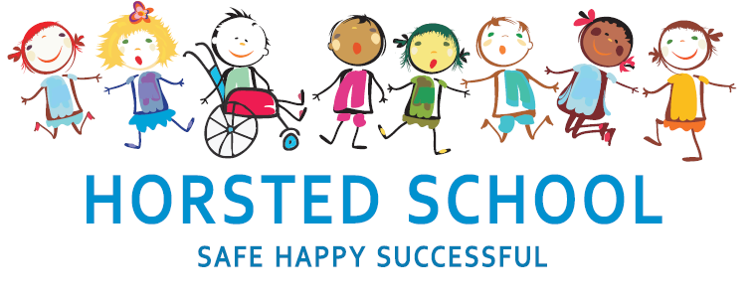
ART AND DESIGN POLICY

Horsted school is a vibrant, safe and welcoming school where we celebrate and welcome differences within our school community. The ability to learn is underpinned by the teaching of basic skills, knowledge, concepts and values with a vision to prepare pupils for a happy and healthy life beyond primary school.
Our vision for Horsted School is that our children will leave us with a genuine enthusiasm for learning and as
- Striving (they will be determined, persevere and they will be resilient);
- Thoughtful (They will be creative, logical and curious about their world and those around them);
- Aspirational (personally, emotionally and academically);
- Respectful (of themselves, others and their environment) and;
- Supportive (of themselves, others and their wider community) individuals.

Aim and purpose
We aim to achieve this through our curriculum’s rich web and in partnership with parents. The curriculum at Horsted is designed to provide an enjoyable, broad and balanced education that meets the needs of all children. It provides opportunities for children to develop as independent, confident and successful learners, with high aspirations, who know how to make a positive contribution to their community and the wider society.
Horsted is an inclusive school. We strive to ensure that all children will be able to access the curriculum or make necessary modifications to it in order to achieve this.

Review date | March 2020
Reviewed by | Charlotte Thumwood
Next Review | March 2023

Approved by

Headteacher: ______________________________________ Date: ___________________

Chair of Governors: _________________________________ Date: ___________________
ART AND DESIGN POLICY

“Art, craft and design embody some of the highest forms of human creativity. A high-quality art and design education should engage, inspire and challenge pupils, equipping them with the knowledge and skills to experiment, invent and create their own works of art, craft and design. As pupils progress, they should be able to think critically and develop a more rigorous understanding of art and design. They should also know how art and design both reflect and shape our history, and contribute to the culture, creativity and wealth of our nation.”
The 2014 Primary National Curriculum in England, Art and design, page 176

Aims and Purposes:

The national curriculum for art and design aims to ensure that all pupils: produce creative work, exploring their ideas and recording their experiences become proficient in drawing, painting, sculpture and other art, craft and design techniques evaluate and analyse creative works using the language of art, craft and design know about great artists, craft makers and designers, and understand the historical and cultural development of their art forms.

Expectations:

Art and design stimulates creativity and imagination and is an important area of children’s learning from a very early age. It provides visual, tactile and sensory experiences, and a special way of understanding and responding to the world.
During their time at Horsted, children are provided with opportunities to explore and evaluate a broad range of artists’ work and communicate what they see, feel and think through the use of a wide variety of media and techniques in a practical, and creative manner. Our hope is that children experience the power of art and that we ignite a passion for the subject within our children as well as making them aware of the possibilities to express themselves through art.

Our vision for Horsted School is that our children will leave us with a genuine enthusiasm for learning in art and design via our STARS of Striving (they will be determined, persevere and they will be resilient); Thoughtful (They will be creative, logical and curious about their world and those around them); Aspirational (personally, emotionally and academically);Respectful (of themselves, others and their environment) and Supportive (of themselves, others and their wider community) individuals. This is written out in great detail in the Art and Design overview in the section STARS Links.

Organisation and Planning:

Linking with other subjects art is delivered through our thematic Curriculum and links are made across the curriculum within other subjects (please refer to Curriculum Policy). Art planning can be found clearly identified on Long-Term and Medium-Term Plans and embedded within planning. Children build upon prior learning to give a progression through year groups. This is identified and monitored using Target Tracker. Children are given the opportunity to work as a class, as part of a group or as an individual. The choice of class organisation will be determined by the learning task or activity, the nature of the theme and the resources being used.

Children in the Foundation Stage are given the opportunity to explore and use media and materials and to be imaginative through basic and enhanced provision. Children are given sufficient time to develop mastery of skills and opportunities and we celebrate innovation and are sensitive to personal feelings, values and attitudes.

Assessment, recording and reporting:

Each child’s performance in Art and Design will be assessed by the teacher using ongoing formative assessment. Formative assessment is ongoing assessment used to monitor student learning in order to provide feedback that can be used to improve teaching and learning outcomes. Teachers record learning outcomes in a termly assessment book and summative assessments are recorded. Summative assessments indicate if the teacher thinks the child is working towards the expected level, at the expected level or at greater depth.
We check pupils’ understanding systematically and effectively in lessons, offering clearly directed and timely support, i.e. moving children on from their starting points, providing different starting points and addressing misconceptions at the point of need. We provide children with incisive verbal feedback, about what they can do to improve their knowledge, understanding and skills.
Children are given opportunities to self-assess their own achievement and progress through the self-selection of ‘wow’ pieces throughout the year. Teachers pass on information and KS2 use sketchbooks to promote and show knowledge and progression made throughout each year. We consider both the quality of the products that the children make and the skills they exhibit as they use tools, materials and processes. We aim to exceed the expectations by challenging the children to show deeper understanding and mastery in ‘Generating ideas’, ‘Making’, ‘Evaluating’ and ‘Knowledge’ and extend their learning beyond the confines of a task.

Inclusion and differentiation

In order to provide all pupils with relevant and appropriate work at each stage, we:
- Set suitable learning challenges
- Respond to pupils’ diverse needs
- Endeavour to overcome potential barriers to learning
- Provide further opportunities to deepen and extend skills and knowledge within the context for those who consistently make more progress

The Role of the Subject Leader

- To advise colleagues, where necessary, on the development of planning and delivering the curriculum.
- To keep up to date with developments in design and technology education passing this on to other members of staff.
- To monitor and evaluate progress and outcomes in design and technology, supported by the progression document for Art and liaise with senior leadership on any action necessary.
- To liaise with appropriate bodies e.g. other primary and secondary schools, governors, the LEA etc. concerning matters relating to design and technology.
- To monitor learning in design and technology by working alongside colleagues and by viewing children's achievements.

Resources

General art materials are ordered by the art coordinator and are kept in the art room and storage areas. Colleagues record in the main storage room what is needed, for the Art coordinator to act upon. Key Stage teams order resources specific to their thematic curriculum to ensure they have the necessary materials.

Health and safety:

When working with tools, equipment and materials, in practical activities and in different environments, including those that are unfamiliar, pupils should be taught:
- about hazards, risks and risk control.
- to recognise hazards, assess consequent risks and take steps
- to control the risks to themselves and others.
- to use the information to assess the immediate and cumulative risks.
- to manage the environment to ensure the health and safety of themselves and others.
- to explain the steps they take to control risks.

