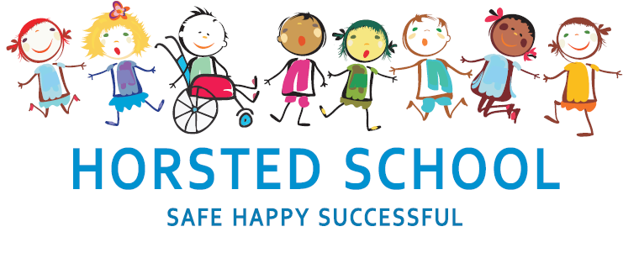
LANGUAGES POLICY

Horsted school is a vibrant, safe and welcoming school where we celebrate and welcome differences within our school community. The ability to learn is underpinned by the teaching of basic skills, knowledge, concepts and values with a vision to prepare pupils for a happy and healthy life beyond primary school.
Our vision for Horsted School is that our children will leave us with a genuine enthusiasm for learning and as
- Striving (they will be determined, persevere and they will be resilient);
- Thoughtful (They will be creative, logical and curious about their world and those around them);
- Aspirational (personally, emotionally and academically);
- Respectful (of themselves, others and their environment) and;
- Supportive (of themselves, others and their wider community) individuals.

Aim and purpose
We aim to achieve this through our curriculum’s rich web and in partnership with parents. The curriculum at Horsted is designed to provide an enjoyable, broad and balanced education that meets the needs of all children. It provides opportunities for children to develop as independent, confident and successful learners, with high aspirations, who know how to make a positive contribution to their community and the wider society.
Horsted is an inclusive school. We strive to ensure that all children will be able to access the curriculum or make necessary modifications to it in order to achieve this.

Review date | March 2020
Reviewed by | Laura Packman
Next Review | March 2023

Approved by

Headteacher: ______________________________________ Date: ___________________

Chair of Governors: _________________________________ Date: ___________________
LANGUAGES POLICY

‘Learning a foreign language is a liberation from insularity and provides an opening to other cultures. A high-quality languages education should foster pupils’ curiosity and deepen their understanding of the world. The teaching should enable pupils to express their ideas and thoughts in another language and to understand and respond to its speakers, both in speech and in writing. It should also provide opportunities for them to communicate for practical purposes, learn new ways of thinking and read great literature in the original language. Language teaching should provide the foundation for learning further languages, equipping pupils to study and work in other countries.’ (DfE 2014)

Our aim is to develop the confidence and competence of each child in the foreign language they are learning. Our goal is for them to be passionate, curious and confident about their own foreign language learning abilities when they finish the primary school phase of their education.

We will help them develop and demonstrate substantial progress in the 5 key language skills necessary for learning French:
∙ Speaking
∙ Listening
∙ Reading
∙ Writing
∙ Grammar

We aim to ensure that pupils of all abilities develop solid foundations in these key language learning skills - properly preparing them for the next stage of their language learning journey. These skills will develop children’s ability to understand what they hear and read and enable them to express themselves in speech and writing. We will extend their knowledge of how language works and explore the similarities and differences between the foreign language they are learning and English. We will also help strengthen their sense of identity through learning about culture in other countries and comparing it with their own.

Expectations:

By the end of each key stage, pupils are expected to know, apply and understand the matters, skills and processes specified in the relevant programme of study. (DfE 2014)

Organisation and Planning:

French is taught in a whole-class setting by the KS2 class teachers who plan their lessons using the LCP scheme of work and can supplement this with their own ideas and experience and those of their colleagues. This is no requirement to teach languages to pupils in EYFS and KS1
The lessons are designed to motivate, captivate and interest children from the first moment. They have clear, achievable objectives and incorporate different learning styles. SEN children have access to the curriculum through variation of task, grouping or support from an adult.
Each class has a timetabled lesson of at least thirty minutes per week. In addition to this, French can also be revisited in short sessions throughout the week to consolidate knowledge and ensure new language is retained as appropriate. There are 5 units planned into curriculum time for each KS2 class allowing time for revision of skills and knowledge covered in the units towards the end of the year.

Assessment, recording and reporting:

Each child’s performance in Languages will be assessed by the teacher against the end of key stage expectations using Target Tracker. Pupil progress will be reported to parents at the 3 identified opportunities throughout the year (see curriculum policy).

Inclusion and differentiation:

In order to provide all pupils with relevant and appropriate work at each stage, we:
- Set suitable learning challenges
- Respond to pupils’ diverse needs
- Endeavour to overcome potential barriers to learning

The Role of the Subject Leader:

- To advise colleagues, where necessary, on the development of planning and delivering the curriculum.
- To keep up to date with developments in Languages education passing this on to other members of staff.
- To monitor and evaluate progress and outcomes in Languages, supported by the progression document for Languages and liaise with senior leadership on any action necessary.
- To liaise with appropriate bodies e.g. other primary and secondary schools, governors, the LEA etc. concerning matters relating to design and technology.
- To monitor learning in Languages by working alongside colleagues and by viewing children's achievements.

Resources:

The LCP teaching folders are located in the Hub in the junior building. Flashcards and photocopiable resources can be taken from there. The use of internet resources such as Linguafun is encouraged to add breadth and variety in lessons.

Health and safety:

