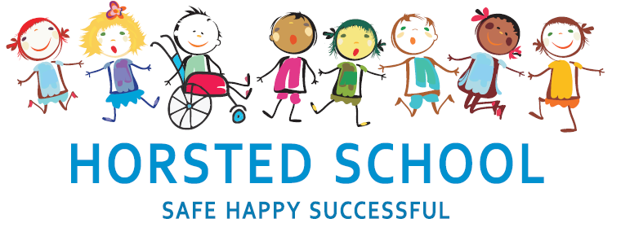
GEOGRAPHY POLICY

Horsted school is a vibrant, safe and welcoming school where we celebrate and welcome differences within our school community. The ability to learn is underpinned by the teaching of basic skills, knowledge, concepts and values with a vision to prepare pupils for a happy and healthy life beyond primary school.
Our vision for Horsted School is that our children will leave us with a genuine enthusiasm for learning and as
- Striving (they will be determined, persevere and they will be resilient);
- Thoughtful (They will be creative, logical and curious about their world and those around them);
- Aspirational (personally, emotionally and academically);
- Respectful (of themselves, others and their environment) and;
- Supportive (of themselves, others and their wider community) individuals.

Aim and purpose
We aim to achieve this through our curriculum’s rich web and in partnership with parents. The curriculum at Horsted is designed to provide an enjoyable, broad and balanced education that meets the needs of all children. It provides opportunities for children to develop as independent, confident and successful learners, with high aspirations, who know how to make a positive contribution to their community and the wider society.
Horsted is an inclusive school. We strive to ensure that all children will be able to access the curriculum or make necessary modifications to it in order to achieve this.

Review date | March 2020
Reviewed by | Laura Packman
Next Review | March 2023

Approved by

Headteacher: ______________________________________ Date: ___________________

Chair of Governors: _________________________________ Date: ___________________
GEOGRAPHY POLICY

‘A high-quality geography education should inspire in pupils a curiosity and fascination about the world and its people that will remain with them for the rest of their lives. Teaching should equip pupils with knowledge about diverse places, people, resources and natural and human environments, together with a deep understanding of the Earth’s key physical and human processes. As pupils progress, their growing knowledge about the world should help them to deepen their understanding of the interaction between physical and human processes, and of the formation and use of landscapes and environments. Geographical knowledge, understanding and skills provide the framework and approaches that explain how the Earth’s features at different scales are shaped, interconnected and change over time.’
(DfE National Curriculum 2014)

Aims and purposes
Our Geography curriculum aims to ensure all pupils:
∙ develop contextual knowledge of the location of globally significant places including their defining physical and human characteristics and how these provide a geographical context for understanding the actions of processes
∙ understand the processes that give rise to key physical and human geographical features of the world, how these are interdependent and how they bring about spatial variation and change over time
∙ are competent in the geographical skills needed to:
- collect, analyse and communicate with a range of data gathered through experiences of fieldwork that deepen their understanding of geographical processes
- interpret a range of sources of geographical information, including maps, diagrams, globes, aerial photographs and Geographical Information Systems (GIS)
- communicate geographical information in a variety of ways, including through maps, numerical and quantitative skills and writing at length.

The content of the school curriculum aims:

To ensure all pupils in Key Stage 1:
∙ develop knowledge of the world, the United Kingdom and their locality
∙ understand basic subject-specific vocabulary relating to human and physical geography
∙ begin to use geographical skills, including first-hand observation to enhance their locational awareness.

To ensure all pupils in Key Stage 2:
∙ extend their knowledge and understanding beyond the local area to include the United Kingdom and Europe, North and South America
∙ include the location and characterisation of a range of the world’s most significant human and physical features
∙ develop their use of geographical knowledge, understanding and skills to enhance their locational and place knowledge.

STARS
Through learning the Geography curriculum, pupils will
Strive - In Geography, children will have to strive when learning about different localities when they learn to compare them. They will need to persevere and be resilient in their fieldwork.
Thoughtful - Children will be encouraged to think about localities in a thoughtful manner - how has the land usage changed over time? What data can be gathered about it?
Aspirational - children will aim to achieve well in their Geography lessons and will present their work in a range of different ways.
Respectful - Children will learn about a range of different environments and consider the impact that human beings have on them. They will think about ways that we can look after our environment and be respectful to it.
Supportive - During fieldwork and various other Geographical learning experiences, children will work in groups. Learning will be underpinned by good team work practices.

Expectations:

By the end of each key stage, pupils are expected to know, apply and understand the matters, skills and processes specified in the relevant programme of study. (DfE 2014)

Organisation and Planning:

Geography is one of the main topic drivers at Horsted and we use it as a vehicle for cross curricular links into other subjects being mindful that we do not lose sight of our learning intentions. Content and coverage has been allocated to promote what we think would allow for the best possible progression within the subject. Resources such as Digi-Maps, where possible, are used in order to engage children in their learning.

Geography planning can be found clearly identified on Long-Term and Medium-Term Plans and embedded within Short-term planning. Teachers draw learning from a range of sources, however, lessons are primarily derived from the Geographical Association plans due to their rigorous approach. Children build upon prior learning to give a progression through year groups. Children are given the opportunity to work as a class, as part of a group or as an individual. The choice of class organisation will be determined by the learning task or activity, the nature of the theme and the resources being used.

Assessment, recording and reporting:

Each child’s performance in Geography will be assessed by the teacher using ongoing formative assessment. Formative assessment is ongoing assessment used to monitor student learning in order to provide feedback that can be used to improve teaching and learning outcomes. Teachers record learning outcomes in a termly assessment book and summative assessments are recorded. Summative assessments indicate if the teacher thinks the child is working towards the expected level, at the expected level or at greater depth.

We check pupils’ understanding systematically and effectively in lessons, offering clearly directed and timely support, i.e. moving children on from their starting points, providing different starting points and addressing misconceptions at the point of need. We provide children with incisive verbal feedback, about what they can do to improve their knowledge, understanding and skills.

Inclusion and differentiation:

In order to provide all pupils with relevant and appropriate work at each stage, we:
- Set suitable learning challenges
- Respond to pupils’ diverse needs
- Endeavour to overcome potential barriers to learning

The Role of the Subject Leader:

- To advise colleagues, where necessary, on the development of planning and delivering the curriculum.
- To keep up to date with developments in design and technology education passing this on to other members of staff.
- To monitor and evaluate progress and outcomes in design and technology, supported by the progression document for Geography and liaise with senior leadership on any action necessary.
- To liaise with appropriate bodies e.g. other primary and secondary schools, governors, the LEA etc. concerning matters relating to design and technology.
- To monitor learning in design and technology by working alongside colleagues and by viewing children's achievements.

Resources:

Resources are stored for Geography throughout the school.
Atlases for KS1 are in the KS1 library
Atlases for KS2 are in ‘The Little Room’.
Various other resources such as weather stations and compasses etc are stored in the Science cupboard.
Any requests for new resources or queries about existing resources should be passed to the Geography subject leader.

Health and safety:

When working with tools, equipment and materials, in practical activities and in different environments, including those that are unfamiliar, pupils should be taught:
about hazards, risks and risk control.
- to recognise hazards, assess consequent risks and take steps
- to control the risks to themselves and others.
- to use the information to assess the immediate and cumulative risks.
- to manage the environment to ensure the health and safety of themselves and others.
- to explain the steps they take to control risks.

