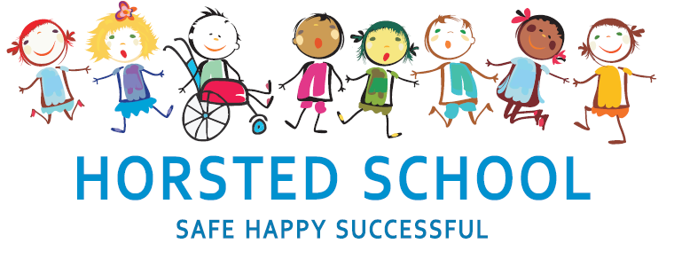
DESIGN AND TECHNOLOGY POLICY

Horsted school is a vibrant, safe and welcoming school where we celebrate and welcome differences within our school community. The ability to learn is underpinned by the teaching of basic skills, knowledge, concepts and values with a vision to prepare pupils for a happy and healthy life beyond primary school.
Our vision for Horsted School is that our children will leave us with a genuine enthusiasm for learning and as
- Striving (they will be determined, persevere and they will be resilient);
- Thoughtful (They will be creative, logical and curious about their world and those around them);
- Aspirational (personally, emotionally and academically);
- Respectful (of themselves, others and their environment) and;
- Supportive (of themselves, others and their wider community) individuals.

Aim and purpose
We aim to achieve this through our curriculum’s rich web and in partnership with parents. The curriculum at Horsted is designed to provide an enjoyable, broad and balanced education that meets the needs of all children. It provides opportunities for children to develop as independent, confident and successful learners, with high aspirations, who know how to make a positive contribution to their community and the wider society.
Horsted is an inclusive school. We strive to ensure that all children will be able to access the curriculum or make necessary modifications to it in order to achieve this.

Review date | March 2020
Reviewed by | Laura Packman
Next Review | March 2023

Approved by

Headteacher: ______________________________________ Date: ___________________

Chair of Governors: _________________________________ Date: ___________________
DESIGN AND TECHNOLOGY POLICY

‘Design and Technology is an inspiring, rigorous and practical subject. Using creativity and imagination, pupils design and make products that solve real and relevant problems within a variety of contexts, considering their own and others’ needs, wants and values. They acquire a broad range of subject knowledge and draw on disciplines such as mathematics, science, engineering, computing and art. Pupils learn how to take risks, becoming resourceful, innovative, enterprising and capable citizens. Through the evaluation of past and present design and technology, they develop a critical understanding of its impact on daily life and the wider world. High quality design and technology education makes an essential contribution to the creativity, culture, wealth and well-being of the nation.’ (DfE 2014)

At Horsted School, we are committed to children being able to find out about their world and how things work through opportunities to design and make functional products with a real purpose and user in mind.

‘Children acquire and apply knowledge and understanding of materials and components, mechanisms and control systems, structures, existing products, quality and health and safety. The skills learned in D&T also help with learning across the curriculum. Knowledge about the properties of materials helps in science and the practice of measuring accurately helps in maths. These skills help in IT through the children’s use of computer control and, naturally, in art and design. Design and Technology education helps develop children’s skills through collaborative working and problem-solving, and knowledge in design, materials, structures, mechanisms and electrical control. They are encouraged to be creative and innovative, and are actively encouraged to think about important issues such as sustainability and enterprise.
There are three core activities children engage with in Design and Technology:
- Activities which involve investigating and evaluating existing products
- Focused tasks in which children develop particular aspects of knowledge and skills
- Designing and making activities in which children design and make 'something' for 'somebody' for 'some purpose' These three activities are combined in sequence to create a Design and Technology project.’
(The Design and Technology Association)

We aim to ensure that all pupils are able to:
- develop the creative, technical and practical expertise needed to perform everyday tasks confidently and to participate successfully in an increasingly technological world
- build and apply a repertoire of knowledge, understanding and skills in order to design and make high quality prototypes and products for a wide range of users
- critique, evaluate and test their ideas and products and the work of others understand and apply the principles of nutrition and learn how to cook.

Expectations:

By the end of each key stage, pupils are expected to know, apply and understand the matters, skills and processes specified in the relevant programme of study. (DfE 2014)

Organisation and Planning:

Linking with other subjects DT is delivered through our thematic Curriculum and links are made across the curriculum within other subjects (please refer to Curriculum Policy). DT planning can be found clearly identified on Long-Term and Medium-Term Plans and embedded within planning. Children build upon prior learning to give a progression through year groups. Children are given the opportunity to work as a class, as part of a group or as an individual. The choice of class organisation will be determined by the learning task or activity, the nature of the theme and the resources being used.

Children in the Foundation Stage are given the opportunity to explore and use media and materials and to be imaginative through basic and enhanced provision.

Assessment, recording and reporting:

Each child’s performance in Design and Technology will be assessed by the teacher using ongoing formative assessment. Formative assessment is ongoing assessment used to monitor student learning in order to provide feedback that can be used to improve teaching and learning outcomes. Teachers record learning outcomes in a termly assessment book and summative assessments are recorded. Summative assessments indicate if the teacher thinks the child is working towards the expected level, at the expected level or at greater depth.

We check pupils’ understanding systematically and effectively in lessons, offering clearly directed and timely support, i.e. moving children on from their starting points, providing different starting points and addressing misconceptions at the point of need. We provide children with incisive verbal feedback, about what they can do to improve their knowledge, understanding and skills.

Inclusion and differentiation:

In order to provide all pupils with relevant and appropriate work at each stage, we:
- Set suitable learning challenges
- Respond to pupils’ diverse needs
- Endeavour to overcome potential barriers to learning

The Role of the Subject Leader:

- To advise colleagues, where necessary, on the development of planning and delivering the curriculum.
- To keep up to date with developments in design and technology education passing this on to other members of staff.
- To monitor and evaluate progress and outcomes in design and technology, supported by the progression document for DT and liaise with senior leadership on any action necessary.
- To liaise with appropriate bodies e.g. other primary and secondary schools, governors, the LEA etc. concerning matters relating to design and technology.
- To monitor learning in design and technology by working alongside colleagues and by viewing children's achievements.

Resources:

A limited number of tools (e.g. hammers, clamps, junior hack saws) and non-consumable items can be found in the DT cupboard located in the DT cupboard near to the KS2 hall. Food preparation and cooking equipment is to be found in the link corridor between KS1 and KS2.

Health and safety:

When working with tools, equipment and materials, in practical activities and in different environments, including those that are unfamiliar, pupils should be taught:
about hazards, risks and risk control.
- to recognise hazards, assess consequent risks and take steps
- to control the risks to themselves and others.
- to use the information to assess the immediate and cumulative risks.
- to manage the environment to ensure the health and safety of themselves and others.
- to explain the steps they take to control risks.

Teachers will include in their medium/short term planning, a risk assessment outlining tools and materials which could pose a possible risk to pupils/staff using them. This can be found under the heading of “Associated Risks” and is highlighted for easy reference.

