School | Horsted School
Total Catch up Premium |  | £34,080 | Number of Pupils | 426
Total School Led tutoring Grant |  | £7290 | 150 hours in the infants | 390 hours in the juniors

Please note that this is a live document and updates will be added periodically to account for further spending from the Catch-up budget.
Guidance
Children and young people across the country have experienced unprecedented disruption to their education as a result of coronavirus (COVID-19). Those from the most vulnerable and disadvantaged backgrounds will be among those hardest hit. The aggregate impact of lost time in education will be substantial, and the scale of our response must match the scale of the challenge. Schools’ allocations will be calculated on a per pupil basis, providing each mainstream school with a total of £80 for each pupil in from Reception through to Year 6 (Year 11 at high school). As the catch-up premium has been designed to mitigate the effects of the unique disruption caused by coronavirus (COVID-19), the grant will only be available for the 2020 to 2021 academic year. It will not be added to schools’ baselines in calculating future years’ funding allocations.
The school led tutoring grant is a one off payment that is ring fenced for pupils to receive additional teaching time in order to address gaps in learning as a result of COVID lockdowns. In 2021/22 it is used to fund 75% of additional teaching time with the remaining 25% coming from the Recovery Premium. Both payments are one offs which are calculated based on the number of disadvantaged pupils on school roll, however, the school is able to spend this money on pupil who they think was disproportionately affected by COVID- 19 lockdowns.
Use of Funds | EEF recommendations
Schools should use this funding for specific activities to support their pupils to catch up for lost teaching over the previous months, in line with the guidance on curriculum expectations for the next academic year. Schools have the flexibility to spend their funding in the best way for their cohort and circumstances.  To support schools to make the best use of this funding, the Education Endowment Foundation (EEF) has published a coronavirus (COVID-19) support guide for schools with evidence-based approaches to catch up Schools should use this document to help them direct their additional funding in the most effective way. | The EEF advises the following:  Teaching and whole school strategies  ⮚ Supporting great teaching  ⮚ Pupil assessment and feedback  ⮚ Transition support  Targeted approaches  ⮚ One to one and small group tuition  ⮚ Intervention programmes  ⮚ Extended school time for all students.  Wider strategies  ⮚ Supporting parent and carers  ⮚ Access to technology  ⮚ Summer support

Identified Impact of Lockdown
Maths | Specific content has been missed, leading to gaps in learning and stalled sequencing of journeys. Children still have an appetite for maths and lockdown has not affected their attitudes however they are quite simply, ‘behind’. Recall of basic skills has suffered – children are not able to recall addition facts, times tables and have forgotten once taught calculation strategies. This is reflected in arithmetic assessments.
Writing | Children have not necessarily missed ‘units’ of learning in the same way as Maths, however they have lost essential practising of writing skills. Grammar and punctuation specific knowledge has suffered, leading to lack of fluency in writing. Those who have maintained writing throughout lockdown are less affected, however those who evidently did not write much have had to work additionally hard on writing stamina and improving their motivation due to the lack of fluency in their ability to write.
Reading | Children accessed reading during lockdown more than any other subject. This is something that was more accessible for families and required less teacher input. However, children are less fluent in their reading and the gap between those children that read widely and those children who did not is now increasingly wide. The bottom 20% of readers have been disproportionately affected.
Non-core | There are now gaps in knowledge –units of work have not been taught meaning that children are less able to access pre-requisite knowledge when learning something new and they are less likely to make connections between concepts and themes throughout the curriculum. Children have also missed out on the curriculum experiences e.g. trips, visitors and powerful curriculum moments. Key skills have been missed in foundation subjects and staff need to be aware of this in order to address this in their planning.
Wellbeing | Children returned to school in September with less focus than would have been expected following a summer holiday and with some anxieties. Behaviour on the playgrounds appears to be positive and pupils relish the opportunity to play with their friends in smaller groups due to staggered playtimes. Once pupils settled in with their new classes, their anxieties appeared to ease. Resilience in work appears to have been affected.

Teaching and Whole School Strategies
Desired Outcome | Action  (intended spend)  (actual spend) | Impact (once reviewed)
Supporting great teaching  Despite the limitations placed on schools in terms of use of physical resources and the sharing of them, manipulatives are accessed regularly in Maths and this supports teaching and learning. In addition, reading books need to be quarantined and the library is out of action. Therefore, there is a need to increase the amount of reading scheme books we have available across all age phases to send between home and school.  The foundation subjects will require closer focus to skills and greater awareness of previous year group to ensure that skills are appropriately closed and are progressive within subjects.  From September 2021 or whenever COVID restrictions allow, early career teachers will have further opportunities to develop their practice with additional chances to observe good practice and attend early career development practices | Purchase of additional RWI books  (£3000)  (£3115) | Academic year 2020-2021  94% of children made expected progress in Reading in Year 1 and year 2 with 35% making more than expected progress in academic year 2020-2021  63% of children in EYFS made expected progress in Reading in EYFS with 5% making more than expected progress in academic year 2020 – 2021 (EYFS were affected by bubble closures during the course of the year)  December 2020 – 84% of children passed the phonics screen. This was taken in year 2 rather than year 1.  Academic year 2021 -2022  64.2% of children currently on track in year 1 and year 2 at the end of term 3 – Year 1 currently being supported with reading and certain children are beginning to be picked up by SENCo.  66% on track in RWI in year R with 26% nearly there in addition.  55% on track in year 1 with 15% nearly there in addition. Further support is being offered in year 1 through further tutoring and SENCo completing one afternoon a week in there.  93% of EYFS are currently on track in Literacy ELG.  December 2021 – 88% of children passed the phonics screen. This was taken in year 2 rather than year 1.  At school council, the children said that they liked RWI because they liked the books that they had to read and it helped them to learn how to read which is good.
 | Purchase of additional reading books from reading scheme for KS2  (£2000)  (£4000) | Academic year 2020 - 2021  New reading scheme books purchased from a range of reading schemes including Big Cat, Literacy trust etc.  Reading books used to supplement higher level reading colours in the juniors.  Impact  Hundred Acre Wood  T1 RA – 7.95 CA – 7.71  T5 RA – 8.11 CA – 8.86  Wonderland  T1 RA – 8.35 CA – 8.91  T5 RA – 9.08 CA – 9.34  Paddington  T1 RA – 9.4 CA – 9.45  T5 RA – 10.03 CA – 10.07  Far Away Tree  T1 RA – 9.69 CA – 10.12  T5 RA – 10.52 CA – 10.63  Middle Earth  T1 RA – 9.88 CA – 10.25  T5 RA – 10.66 CA – 11.12  Neverland  T1 RA – 9.92 CA – 10.38  T5 RA – 10.08 CA – 11.06  Academic year 2021-2022  Percentage of children making the expected progression in reading.  End of term 1 – 86%  End of term 2 - 86%  End of term 3 – 82%  End of term 4 – 91%  Attainment  End of term 1 – 65.7% on track or above  End of term 2 – 69% on track or above  End of term 3 – 73% on track or above  End of term 4 – 73% on track or above  In school council meetings pupils said that they liked the books and felt that they were helpful. They were particularly happy that there are more books at each level to choose from.
 | Purchase of ‘topic’ and science based books for EYFS ‘reading with purpose’  (£1000)  (£739) | Academic year 2020-2021  63% of children in EYFS made expected progress in Reading in EYFS with 5% making more than expected progress in academic year 2020 – 2021 (EYFS were affected by bubble closures during the course of the year)  Academic year 2021 -2022  End of term 4 - 66% on track in RWI in year R with 26% nearly there in addition.  93% of EYFS are currently on track in Literacy ELG.
 | Purchase of letter join to improve the outcomes of handwriting  £464 | Academic year 2020 -2021  The system was trialled after noting the impact that COVID lockdowns had on handwriting, especially the handwriting in the younger years in the school.  Academic year 2021 – 2022  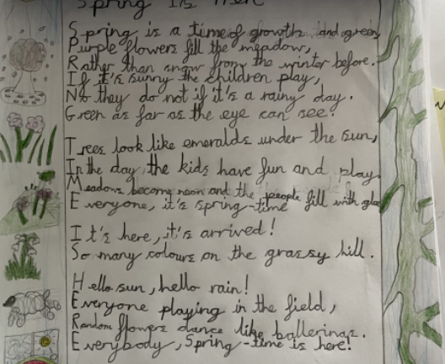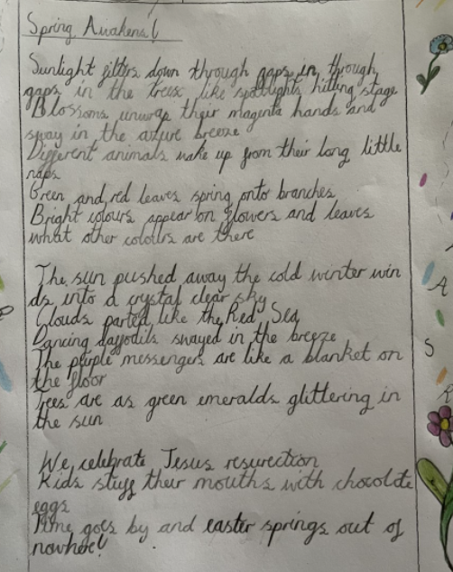  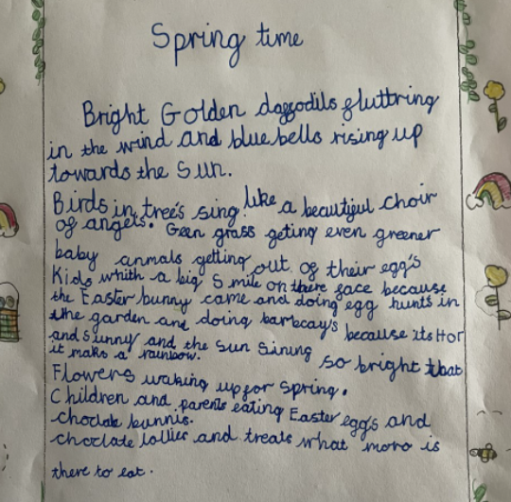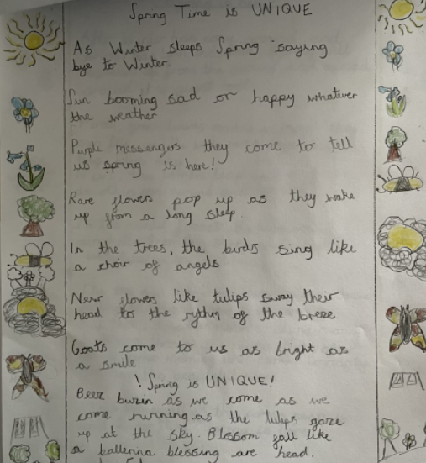
 | Purchase of Hamilton Trust for staff to refer to for planning (£135)  (£135) | Academic year 2020-2021  Limited impact.  Some evidence of the use of resources in book looks and learning walks but insufficient to justify purchasing the resource again.
 | Additional training course to be found for those members of staff who are newer in their professional journey.  (not to exceed £35000 – to include training sessions)  NC - £1676  DT course - £500  Science course - £140  Coram life ed - £25  Chris Quigley ‘making it stick’ - £160  CPD library - £270  Total - £2,771 | Academic year 2021 - 2022  The National College was purchased for all staff.  National College used to renew FGM training for all staff.  Geography lead used a NC webinar video in staff meeting about teaching mastery in the Geography curriculum. This was fed back to staff who commented that they felt more confident in their understanding of Geography  Middle leaders have been using the NC to investigate Deep Dives for Ofsted by watching videos about intent, implementation and impact.  T5 – all teaching staff to watch video about cognitive science and process of remembering and how this features in the classroom.  Subject leaders went on DT and Science course. From this, DT was covered in staff meeting with staff knowledge audited. Resilience and problem solving was discussed – how DT can encourage these skills and personality developments. The feedback from the DT course led to MLs being empowered to give feedback to EYFS about a making activity that could have allowed the children to problem solve by explore the properties of materials in a more independent way.  Science course led to a successful science week across the school raising the profile of the subject across the school. This included pupils completing an ‘off curriculum’ science experiment (see photos in curriculum books) to add enrichment to the pupils and widen their life experiences. Pupils also explored a science thinking task daily and made posters about growth.  Chris Quigley training – 2 sessions run in staff meeting time to discuss cognitive load theory and ways of making education ‘sticky’. Work included developing understanding of audio/visual loops and evidence of slightly paired down ppts was seen in learning walks.  We are practitioners – to date, 7 books have been taken out of the staff library.  ‘Writing Revolution’ from the we are practitioners board was used by the English lead as a basis for 3 staff meetings (including 1 INSET) and 3 staff meetings with TAs over the course of the academic year 2021-2022.  Since the staff meetings, staff have been using some of the techniques to teach writing either using sentence jumbles, because,but,so and other note taking/planning strategies.  Intervention groups have also been set up in order to put some of the teaching strategies into practice.  Staff have commented how the staff meetings have made them rethink some of their teaching practices for English e.g the because, but, so activity made one teacher realise that the pupils in her class did not fully understand the meaning of’but’ and so cemented this further before moving onto different conjunctions.
Teaching assessment and feedback  Teachers have a very clear understanding of what gaps in learning remain and use this to inform assessments of learning that are aligned with standardised norms, giving a greater degree in confidence and accuracy of assessments. | Complete end of unit WR tests. Year group previous to be completed prior to unit being taught. (no additional cost) | Academic year 2020 – 2021  KS1 – 90.6% expected progress with 14% making more than expected  69.8% on track (46.7% pp)  KS2 – 87% of pupils making the expected progress with 64% making more than expected  71% on track or above (63% PP)  Academic year 2021 – 2022  KS1 – At T4 – 97% making expected progress with 23% making more than expected  68.3% on track or above (46.7% pp)  KS2 - At T4 – 91% of pupils making expected progress with 40% making more than expected progress  74.4% on track or above (65% pp)  The use of low-key assessments has contributed to high progression in both key stages which has helped to close the gap in attainment caused as a result of lockdown. Results have been used to identify gaps which has been shared with tutors and interventions have been focussed as a result. It has also enabled pre-teaching to be completed in some tutoring to bring children more in line with their peers before a new topic is introduced.
 | Children to complete Salford Reading Tests periodically. (A Sep, B Jan and C April) (no additional cost) | Academic year 2020 - 2021  New reading scheme books purchased from a range of reading schemes including Big Cat, Literacy trust etc.  Reading books used to supplement higher level reading colours in the juniors.  Impact  Hundred Acre Wood  T1 RA – 7.95 CA – 7.71  T5 RA – 8.11 CA – 8.86  Wonderland  T1 RA – 8.35 CA – 8.91  T5 RA – 9.08 CA – 9.34  Paddington  T1 RA – 9.4 CA – 9.45  T5 RA – 10.03 CA – 10.07  Far Away Tree  T1 RA – 9.69 CA – 10.12  T5 RA – 10.52 CA – 10.63  Middle Earth  T1 RA – 9.88 CA – 10.25  T5 RA – 10.66 CA – 11.12  Neverland  T1 RA – 9.92 CA – 10.38  T5 RA – 10.08 CA – 11.06  Academic year 2021 – 2022  Initial tests were completed at the start of the academic year to benchmark pupils’ attainment.  Whilst it is agreed that regular low-stakes assessments are important for the children, SLT discussed that the Salford testing, whilst helpful in identifying the children who need more focus on reading, does not provide information in what aspects of reading the children find hard and often, the test tells teachers the names of children who they already know are struggling.  With this in mind, and with the introduction of reading VIPERS, into school, we instead found a short series of assessment tests that cover main assessment objectives. These tests are completed at the end of every term.  At the time of writing two assessments have been completed thus far and there are plans to create GAP analysis forms so that the tests are used to provide information that will affect ‘on the ground’ teaching i.e. in that it will give a % figure for how many mark the children have for inference etc. This will be rolled out at the start of next academic year.
 | Regularly record assessments on Target Tracker to identify gaps and track performance. (no additional cost) | Academic year 2021 – 2022  Term 5  Thus far, we have had 2 PPMs based on TT data that has been input at the end of the term 1 and term 3.  Individual cases have been discussed and pupils have been identified to receive tutoring during these sessions based on shared understanding of pupils across a year group. The tutoring has either been through the NTP or school led tutoring.  Staff meeting was also conducted about data and how to use Target Tracker can be used by staff to analyse and understand what their data is saying. Staff were thankful of this and the data lead has subsequently been approached a number of times since the meeting to discuss data and check on the processes that go into Target Tracker.  Particular attention was paid to identifying gaps in data such as any attainment gaps between disadvantaged pupils and non.
 | Regular RWI phonics assessments. (no additional cost) | Academic year 2020 – 2021  Year R  T1 – 87%  T2 – 55%  T3 – 42%  T4 – 36%  T5 – 36%  T6 – 47%  (Year R were affected by bubble closures in T2 and national lockdown was in effect during T3 and T4.)  Year 1  T1 – 47%  T2 – 51%  T3 – 40%  T4 – 45%  T5 – 62%  T6 – 64%  Year 2  T1 – 51%  T2 – 43%  T3 – 37%  T4 – 45%  T5 – 76%  T6 – 86%  Regular assessments were completed throughout that year but bubble closures and national lockdowns resulted in slightly lower attainment grades and a dip. Returning to school and regular in-person teaching allowed the chn’s attainment data to increase.  Academic Year 2021 - 2022  Year R  T1 – 88%  T2 – 82%  T3 – 69%  T4 – 66% (with 15 children on 1 step below)  Year 1  Baseline – 28%  T1 – 48%  T2 – 55%  T3 – 48%  T4 – 55%  Year 2  Baseline – 40%  T1 – 57%  T2 – 64%  T3 – 72%  T4 – 75%  Regular assessments throughout the year have enabled teachers in year 1 and year 2 to accelerate the progress of children and therefore achieve higher attainment grades.  Year R have 15 children that are close to being on track – they have been split into 2 smaller groups and speedy sounds interventions (alongside NELI interventions have been started)
Transition Support  Children who are joining school from different settings or who are beginning their schooling with Horsted have an opportunity to become familiar and confident with the setting before they arrive. | A video tour of Horsted School is arranged and shared with all new-starters via the school website. (no additional cost) | Academic year 2020 – 2021  Video of the school is available on the school website. New starters thus far appear to settle in well. Early assessments of their ability are made progress is monitored through ongoing tracking as part of pupil monitoring.  Academic year 2021 – 2022  Parents were able to return on site for visits
Children in year 6 who are transitioning to secondary school may find the transition to secondary school hard following lockdowns and a reduced on-site academic year. | In June/July 2021, where it is needed, FLO to take y6 pupils to secondary school for additional transition where it is needed and there are higher levels of anxiety than normally seen. (not to exceed £500)  £0 | Academic year 2020 – 2021  Owing to ongoing concerns regarding COVID, secondary schools in the local area completed transition in virtual ways this year. They did not have off site visitors attend school meaning that our FLO was unable to complete additional secondary school visits.

Targeted Approach
Desired Outcome | Action  (intended spend)  (actual spend) | Impact (once reviewed)
1:1 and small group tuition  Identified children will have significantly increased rates of reading fluency, writing stamina and basic English skills. | A catch up tutor will be appointed and work with targeted children. Tutors from the NTP will be used.  Funding to be taken from the COVID catch up funding and School Led Tutoring Grant – not to exceed £13,000  Current spend - £11,088 | Academic year 2021 - 2022  End of Term 4
  147 NTP tutoring sessions with 115 students = 27% of the student body
  2,250 hours of additional time learning
  52% based on English
  48% based on Maths
  88 children - 1 round = 1290 hours
  28 children - 2 rounds = 810 hours
  1 child (MM) - 3 rounds = 45 hours
  1 child (CH) - 4 round = 60 hours
  Pupil Premium
  28 sessions of tutoring totalling 390 hours
  22 children (5 have had 2 rounds of tutoring) - represents 40% of the pp children
  SEN
  45 sessions of tutoring totalling 660 hours
  32 children - represents 55% of the SEN children
  Pupils in school council meeting reported: It helps and its fun at the same time it is not boring. Good it makes you understand things. More 1:1 teaching so understand things better.
  KS1
  Maths only (all pupils in y2)
  100% of pupils have made expected progress with 18% of pupils making more than expected progress. Additionally, tutoring in maths is seen to be prompting to same expected progress with SEN and PP pupils. (Data includes children who have not completed their full round of tutoring – 25% more than expected without)
  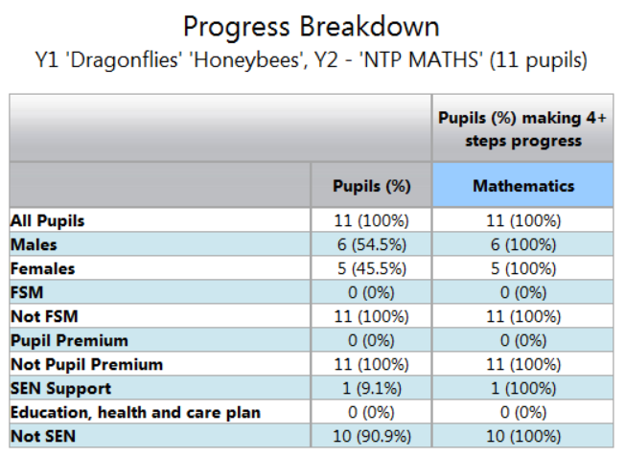
  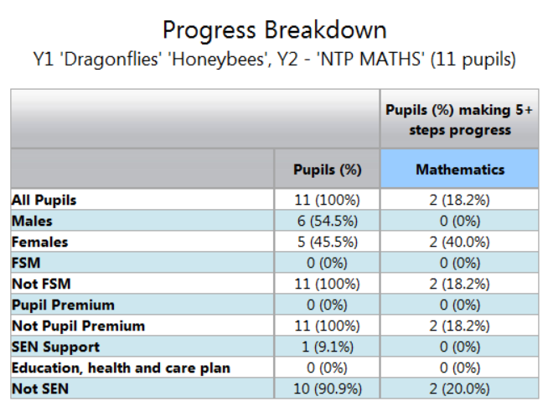
  Writing only (all pupils in year 2)
  100% of pupils have made expected progress with 33% of pupils making more than expected progress.
  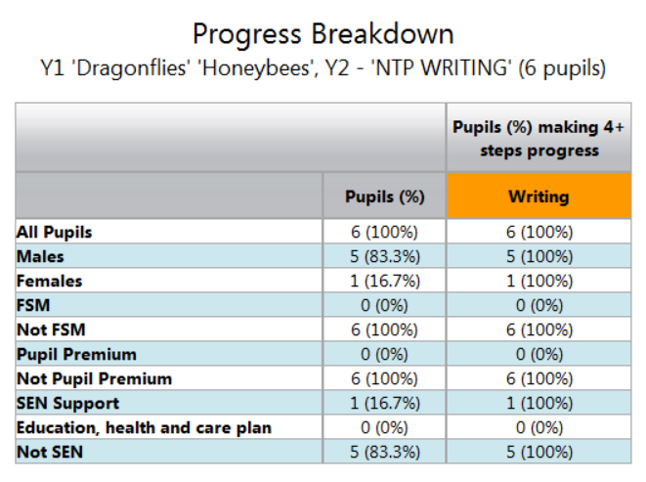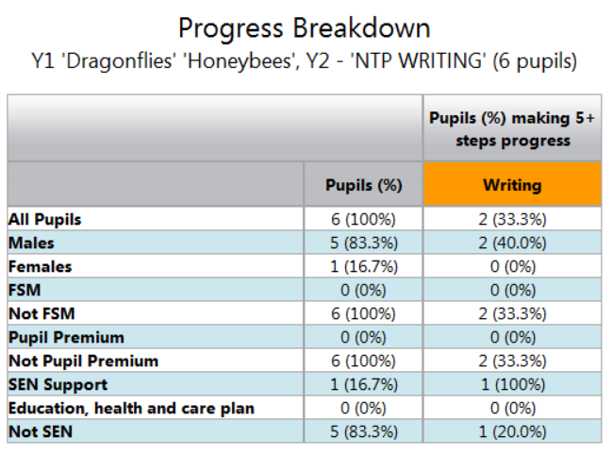
  Reading only (includes year 1 and year 2 – different data range)
  This area has seen the least impact from tutoring despite regular communication between tutor and class teacher.
  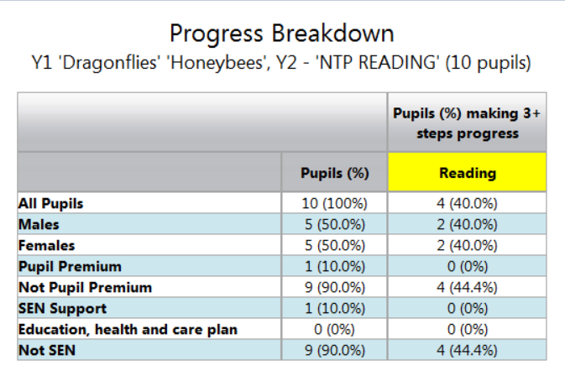
  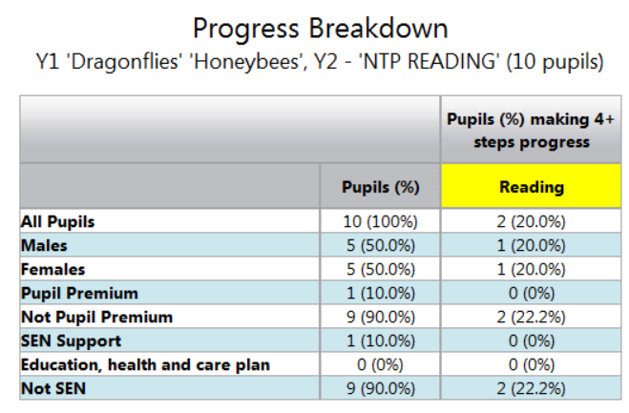
  KS2
  Maths only
  86% of pupils have made expected progress with 41% of pupils making more than expected progress. Additionally, tutoring in maths is seen to be closing the gap between SEN and PP pupils at both levels. (Data includes children who have not completed their full round of tutoring)
  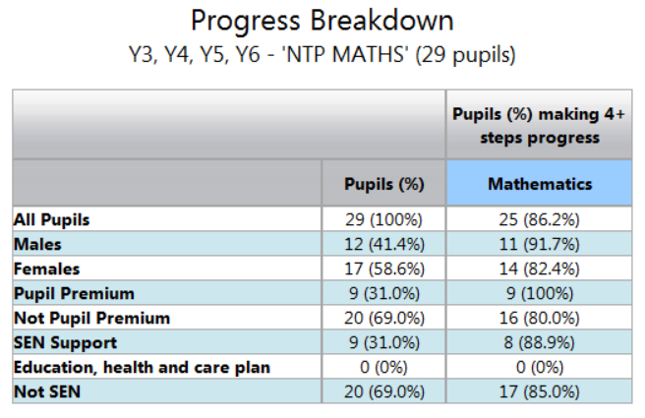
  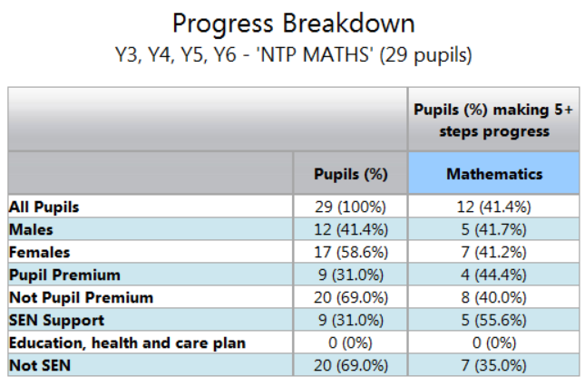
  English – Writing Only
  71% of pupils have made expected progress with 37.5% of pupils making more than expected progress. Additionally, tutoring in maths is seen to be closing the gap between SEN and PP pupils at both levels.
  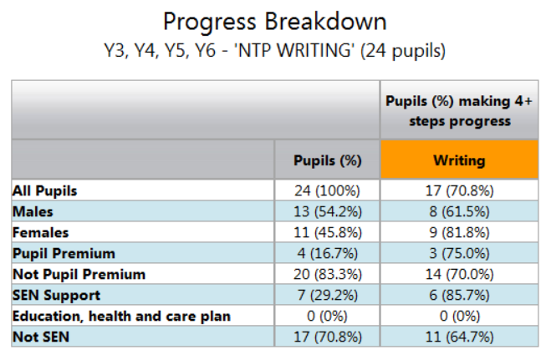
  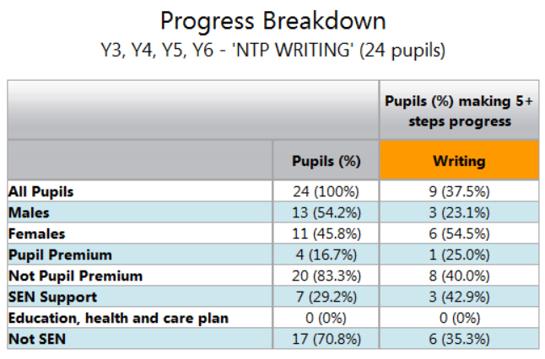
  English – Reading only
  90% of pupils have made expected progress with 70% of pupils making more than expected progress. Additionally, tutoring in maths is seen to be closing the gap between SEN and PP pupils at both levels.
  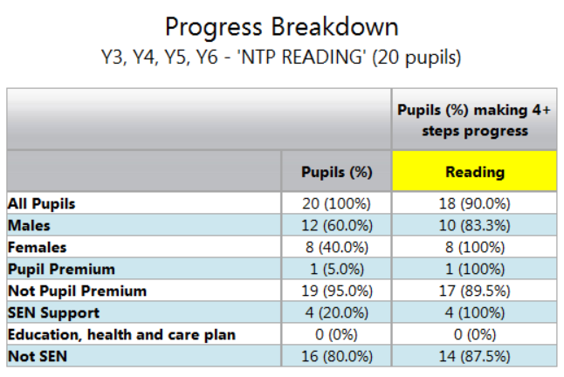
  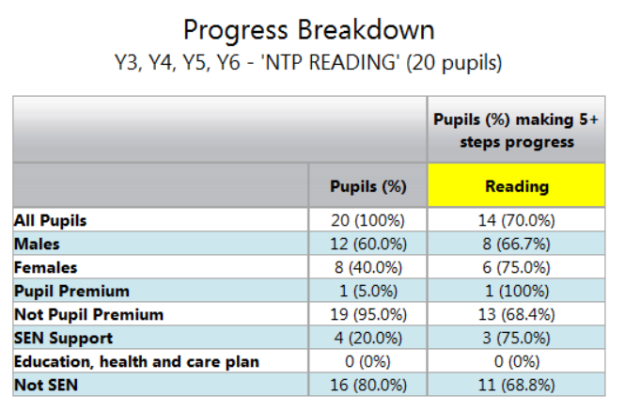
 | School Led Tutoring Grant  Current spend (Term 4)  Infants – 190 hours = -£113 (all budget spent)  Juniors – 353 hours = £2069 remaining of budget | Academic year 2021 - 2022  5 teachers  5 TAs (6 completed the training)  KS1  Year 1 – mixture of all subjects  57% of pupils have made expected progress. SLTG has been the least impactful in year 1.  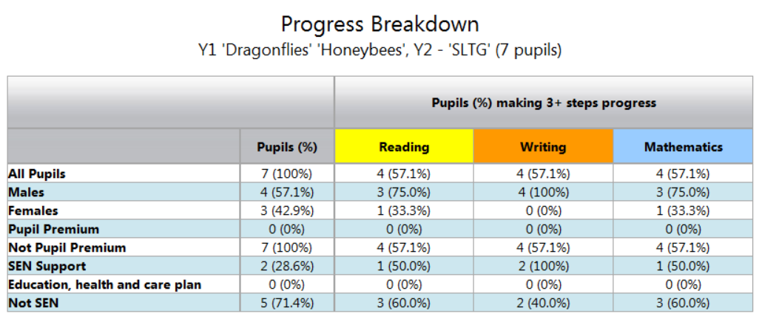  Maths only – year 2  100% of pupils have made expected progress with 66% making more than expected  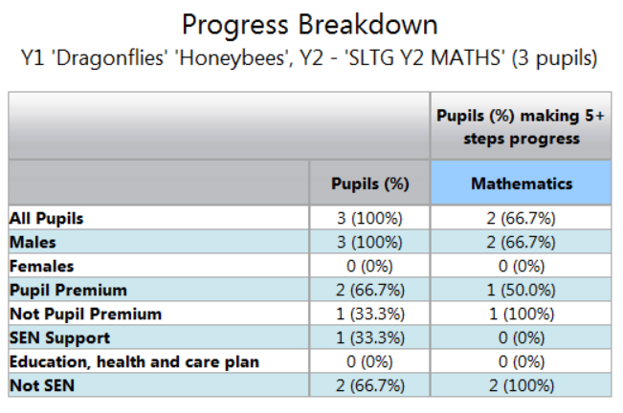  English only – Year 2 (writing focus)  100% of pupils have made expected progress with 25% making more than expected. Note that pupils have not completed their full SLTG allocation.  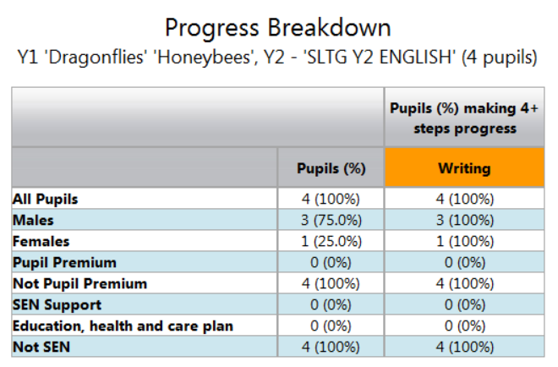  KS2  Those who had maths tutoring – 100% of pupils have made expected progress and 43% of pupils have exceeded expected progress.  See reports below for the vulnerable grouping breakdown.  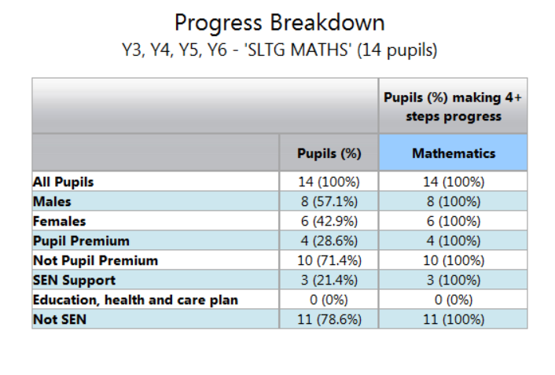  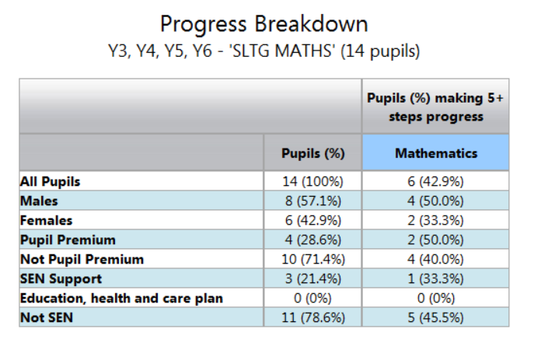  Those who had reading tutoring – 82.4% of pupils have made expected progress and 53% of pupils have exceeded expected progress.  See reports below for the vulnerable grouping breakdown.  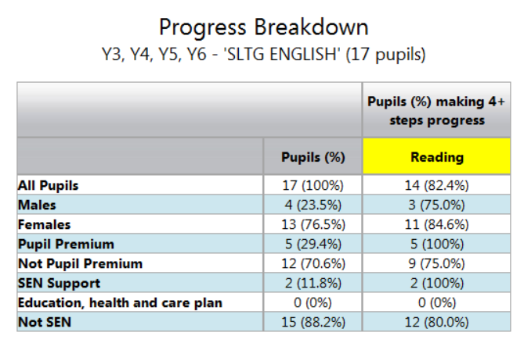  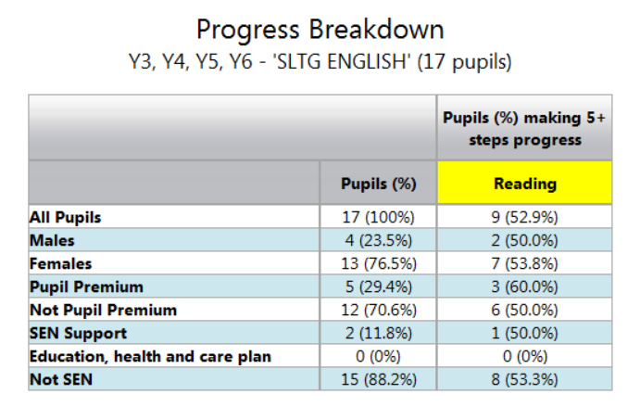
  SLTG
  75% funded from SLTG grant and the rest from COVID catch up
  Infants - £2,025 made up to £2,700 for 150 hours of tutoring
  Juniors = £5,265, made up to £7,020 for 390 hours of tutoring
  INFANTS
  13 chn have received tutoring totalling 190 hours
  Spent all the money -£113
  9 chn have received no prior tutoring
  4 chn have received ntp tutoring prior to this
  2 of the chn are pp children
  2 of the chn are SEN children
  Juniors
  27 children have received tutoring totalling 360 hours
  We have a shortfall of hours but are waiting for one teacher to provide details of another 40 hours of tutoring
  Still have £1205 to spend so we can complete more tutoring after this.
  16 chn have received ntp tutoring prior to this
  11 chn have received ntp tutoring prior to this
  7 chn are pp children
  4 chn are SEN
  Including all of the tutoring thus far
  135 children have had tutoring - 32% of children have received tutoring
  25 pp chn have received tutoring - 43%
  33 SEN chn have received tutoring - 57%
Intervention programme  Children who have been identified will make accelerated progress through appropriate numeracy / English intervention in school. | An additional teacher will be employed for 1 day a week to provide small group intervention for those who need additional work. Interventions will be based on data scrutiny with staff as part of pupil progress meetings. (not to exceed £5000)  Current spend - £3787.50 | Academic Year 2021 – 2022  Year 5 were identified as in need of additional support, particularly with maths.  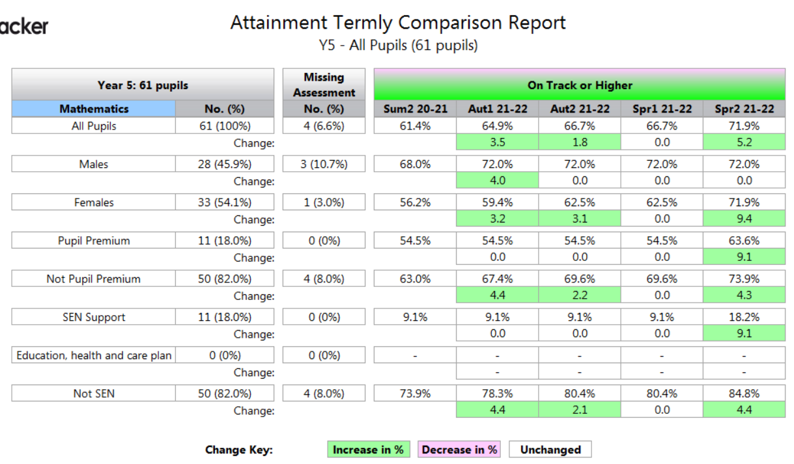  Internal data indicates that all groupings of pupils are now attaining more than at the start of the year as a result of the additional group and that girls attainment gap with the boys has closed as a result.  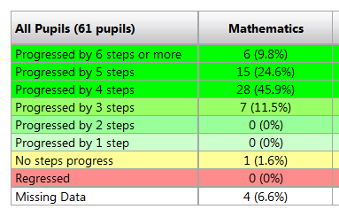  Not only has the attainment data improved, but it is evidenced that all pupils have made the expected progress from their starting point and that 35% of pupils have made more than expected.  1 pupil has made no progress – school refuser  4 pupils are ‘missing’ due to their starting this year and the data range not taking this into account. When the data range closes, these children have made at least the expected progress.
Extended school time  Identified children are able to access a weekly catch-up club. The attainment of those identified children improves and effect of lockdown is becoming negated. Parents are supportive of the club and understand the identification process. | Once the children have settled back into school, a catch-up club to be started in October for 1 evening a week after school. Teachers to identify the children based on their return to school. Teachers to liaise with members of staff running the sessions. (Taken from main budget) | Academic year 2020 - 2021  A small number of catch up after school sessions were completed prior to the January lockdown with fairly large group sizes. It was felt that the once weekly sessions were too infrequent to have to a significant effect as children, on the whole, forgot the previous week’s learning. Some children made small gains but we feel that a tutoring approach might be better going forward with a smaller number of children in each group.  The smaller number of children in the group would provide more targeted teaching and be more intensive and hopefully lead to more substantial gains.

Wider Strategies
Desired Outcome | Action  (intended spend)  (actual spend) | Impact (once reviewed)
Supporting Parents and Carers  Regular communication with parents will continue and parents will be kept informed of their children’s progress.  Supporting parents in home learning when and if this occurs through potential self-isolation of household and bubble closure.  Supporting parents in home learning when and if this occurs through potential self-isolation of household and bubble closure. | Parents evenings to be completed via TEAMS platform. (no additional cost)  Ongoing weekly emails to parents about class achievements and curriculum. (no additional cost) | Academic year 2020 – 2021  November parents evening conducted via TEAMS or via phone call if requested. There was no noticeable reduction in attendance allowing parents to remain informed about their children’s education. Because children were collected at their respective gates and collection points throughout the pandemic where ‘bubbles’ were in force, parents often had informal conversations at the gate with teachers about how their children were getting on and concerns and celebrations were being shared more easily.  Academic year 2021 - 2022  Parents evening during 2021/22 completed on site. The introduction of an online electronic system allowed us to monitor who attended parents evening and enabled parents to book times that were suitable to them rather requesting an appointment within a range of times. It also enabled TAs to remain in class as opposed to liasing with others about sibling appointments.  Infants – November 93% attendance and March 97% attendance  Juniors – November 90% attendance and March 91.4% attendance  These figures are based on those who booked through the online system – some parents booked via phone with the teacher directly and so attendance figures may be higher.
 | All staff will engage with TEAMS training delivered through ADEPT (Taken from main budget) | Academic year 2020 - 2021  Training provided by Adept. The training was very speedy without the opportunity for staff to practice what had been seen in the session. It resulted in some staff confusion and apprehension about the use of TEAMS. It was decided that further training was required in staff meetings.
 | Staff meeting time dedicated to developing staff’s understanding of TEAMS to include screen sharing, use of the class notebook, how to upload files and record lessons. (no additional cost) | Academic year 2020 - 2021  T1 and T2 at least 3 staff meetings were arranged during this time in order to break drown the Adept training that was completed.  Training focussed on setting up meetings including the settings needed for the best safeguarding practises and what to do in the event of a safeguarding concern.  How to use TEAMS class notebook to record work – Year 6 used this function exclusively  How to create quizzes.  How to record lessons either through Microsoft STREAM or via PPT – Year 5 and year 4 used this exclusively so that lesson content could be accessed be parents at a time that suited them and could fit around their work requirements.  Staff were able to deliver elements of live and recorded content for pupils.
 | As part of the January lockdown, photocopied work booklets (alongside TEAMS lessons and recorded sessions) were provided to parents to support their engagement with home learning. More specific resources were also provided. (no additional cost) | Academic year 2020 - 2021  Parents were encouraged fortnightly to pick up work booklets of planned learning activities to link into home learning. It provided an opportunity to keep in contact with the parents who could return work and enabled them to help their pupils engage with home learning more easily.  Parents were very thankful of this and feedback was very positive about the resources that were provided – it also enabled pupils to have access to resources such as clay/paints in order to engage with art based curriculum or those subjects that needed more specific/specialised materials.  For those parents who were unable to attend during the fortnightly pick up session, a station was set up in the main reception where they could collect work at a time that was more suitable for them.
Supporting parents and carers  Homework Club | For those children who are finding completing homework at home challenging, an invite only after school club will be set up consisting of 3 members of staff in order to facilitate the completion of homework.  £500 to come from catch up | Academic year 2020 – 2021  No homework was able to be set up because of mixing children within bubbles.  Academic year 2021 – 2022  Homework club set up. 3 staff are completing the club including a teacher, the family liaison officer (HTLA) and a TA to support children in the completion of their homework.  Pupils can only attend with invitation and in agreement with parents. Parents have welcomed the moved and has reduced the number of LCUs for children who are not completing their homework allowing pupils more opportunities to mix on the playground and enjoy their social times.
Access to tech  Children will have greater opportunities to access learning at home. Home-learning opportunities will not always require parents to engage with the activities, affording the children greater independence and increasing the likelihood that parents can sustain home-learning where it has to occur.  Technology will be used in lessons at school to support ongoing learning and enable children to access high quality online learning resources to help negate the effect of lockdown | All staff will engage with TEAMS training delivered through Atomwide (see above for costing) | Academic year 2020 - 2021  Training provided by Adept. The training was very speedy without the opportunity for staff to practice what had been seen in the session. It resulted in some staff confusion and apprehension about the use of TEAMS. It was decided that further training was required in staff meetings.
 | Staff meeting time dedicated to developing staff’s understanding of TEAMS to include screen sharing, use of the class notebook, how to upload files and record lessons. (no additional cost) | Academic year 2020 - 2021  T1 and T2 at least 3 staff meetings were arranged during this time in order to break drown the Adept training that was completed.  Training focussed on setting up meetings including the settings needed for the best safeguarding practises and what to do in the event of a safeguarding concern.  How to use TEAMS class notebook to record work – Year 6 used this function exclusively  How to create quizzes.  How to record lessons either through Microsoft STREAM or via PPT – Year 5 and year 4 used this exclusively so that lesson content could be accessed be parents at a time that suited them and could fit around their work requirements.  Staff were able to deliver elements of live and recorded content for pupils.
 | Devices will be offered to parents in the event of self-isolation (devices provided foc) | Academic Year 2020 – 2021  All parents were surveyed to ascertain who would need a device in the event of  - Bubble closure  - Lockdown  Laptops and devices were offered to parents when our 4 bubbles closed throughout the academic year of 2020/21.  Parents who requested devices during lockdown 2 had access to them and attendance in online learning improved from the children who previously did not have access to devices.
 | Purchase of the laptop trolley. This will enable all laptops to be charged at once and enable access to more technology in other lessons apart from ICT  6 new laptops bought and added to the laptop trolley  New laptops to be added onto the school network and ensure that all relevant software is added to the devices  (Not to exceed £4000)  Actual spend £3,896.50 | Academic year 2020 – 2021  Devices set up for the purpose of home learning so that children without access to devices were able to engage with learning online.  12 devices were loaned to parents during the second lockdown for their children and these children were actively engaged with home learning.  On return to school, devices remained ready for use in the event that bubbles had to isolate or that individual children who tested positive and were well enough to work were able to continue with their learning.  Academic year 2021 – 2022  Devices were set up so that they could be used in school with a small reserve ready for home learning.  Classes were able to access devices and use them in a range of different lessons – this enabled children greater access to technology.  The tutors have also used the devices extensively to support the children in the NTP tutoring.  About the devices the children said: The laptops are helpful with everything! When questioned further, they said that they enjoyed using them and they were particularly helpful for researching information for their work and helping them learn how to type.
Summer School  Identified children are able to access holiday sessions. The attainment of those identified children improves and effect of lockdown is becoming negated. Parents are supportive of the sessions and understand the identification process. | Easter holiday sessions will be offered for specifically targeted pupils. (£2500)  Actual spend £2821 | Academic year 2020 - 2021  A small number of catch up after school sessions were completed in the Easter holiday with years 1, 4, 5 and 6.  Specifically chosen chn were welcomed into school for 2 hours for both an English and maths session for 5 mornings over the course of one week.  Whilst parents were very pleased to take up the offer of Easter holiday catch up, the feeling amongst staff was the pupils were reluctant to engage because it was their holiday.  Small targets were set for each of the children e.g. to be able to multiply HTO by TO accurately 85% of the time. 72% of the children achieved these small steps that were set, however the learning was not embedded well enough to be able to see an effect on the return to school.  With this in mind, it was felt that a block of time in this manner was not the way forward that we wanted to continue with tutoring. It was decided that keeping extra work to school days and spread out over a number of weeks with a smaller group of children would be more beneficial.
 | Additional time for the Year 6s to focus on basic skills of English and Maths  This is a long-established practice at Horsted and is well attended.  Rest of the funding to go towards the costs | Academic year 2020 – 2021  ‘Pizza Club’ was not completed in this academic year do to the risk of mixing staff and pupils between different academic bubbles.  Academic year 2021 – 2022  82% attendance of the year 6s across the 7 sessions run.  Pupils enjoy ‘Pizza Club’ saying that the extra time helps them with their learning and understanding of basic skills. They say that they like working in the smaller groups at the club as they get more contact time with their adults which helps them concentrate. They say that they are able to use the skills that they learn at ‘Pizza Club’ to help them in their lessons.  91% expected progress as a average in year 6.  (please note – 1 pupil with no progress – school refuser and 2 with missing data were new intake pupils who are not included in the data range)  

