Year 4

 | Term 1 – 7 weeks (just shy) | Term 2 – 7 weeks |  | Term 3 – 6 weeks |  | Term 4 – 6 weeks |  | Term 5 – 5 weeks |  | Term 6 – 7 weeks
BEAR IN MIND | Harvest festival assembly | Dragon’s Den  Make Christmas Cards  Remembrance day |  | Road Safety  Optional tests |  | Mother’s Day  Easter cards?  World Book Day |  | Father’s Day (PTA)  SATs  SHORT TERM! |  | Optional tests  Y4 multiplication tests  Father’s day card
Topic focus and overview | Nutty about Nature | Ancient Civilisations |  | Ancient Egypt |  | Crazy Climates and Barmy Biomes |  | Local environment |  | Rotten Romans
WOW day/visit/guest | Use nature to create a collage.  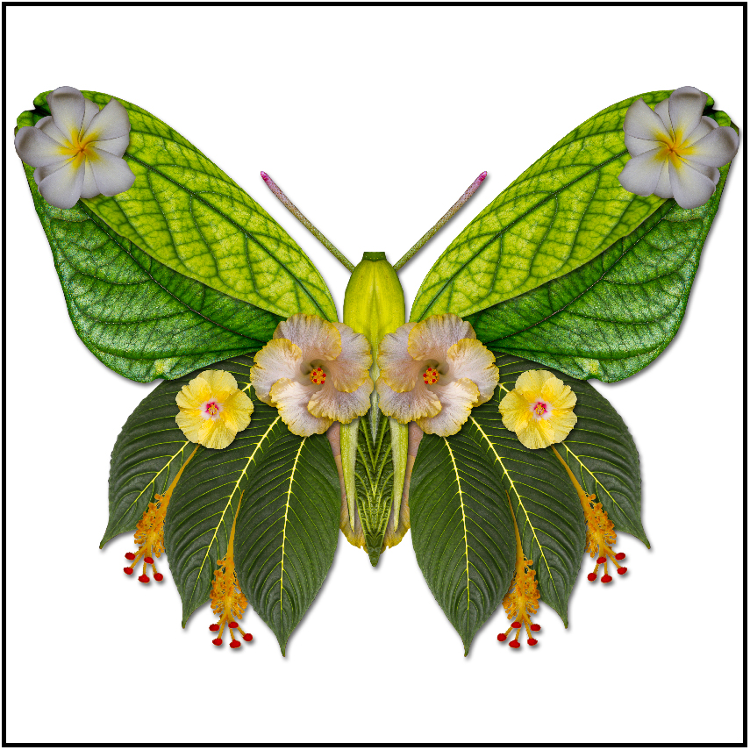Artist SUSAN CLEAVER  Orienteering – Exploring map reading skills to find correct area of the local environment  Bug Hunt – Data gathered from WOW day is used to create bar charts and ascertain the best kind of habitats for invertebrates.  Consideration is given to how to we can use nature to our advantage.  PLANT GARLIC AND ONIONS FOR T6 WHEN THEY WILL COOK WITH THEM | Exploration of Ancient Civilisation inventions – linked to DT Mechanisms  Children design and make shadufs.  Wood work and joining. Linked to science and the reduction of force to achieve an effect – links to T5 science. |  | Maidstone museum (potential to get the train)  Workshop 1 – make clay shabtis – links to making canopic jars in school  Workshop 2 – Handling artefacts and ordered the stages of mummification  Visit around the museum with a particular focus on the Egyptian wing. |  | Making a biome diorama  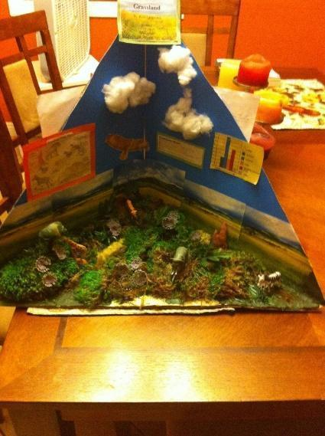  Links to Art and collage use of appropriate and effective materials  Use ICT to research facts  Bar charts of annual average rainfall. |  | Day trip to Rochester including morning at the synagogue and visit the Cathedral to see the art work. Geographical fieldwork of the local town completed focussing on traffic control and litter.  Possibility of Wendy Daws visit on a separate day |  | Design and make a pasta and sauce dish  Make roman shields and swords in order to practice Roman army drills from knowledge previously taught.
Core Text – writing foci | Autumn Poetry with a focus on personification.  The Wind in the Willows  - Descriptive postcard  - Persuasive Letter  - Story | Zet and the mystery of the scroll  - Persuasive Advert  - Newspaper  - Instructions  - Description  - Recount story  - Review  Mummification  - Explanation text |  |  |  | Non-Narrative Writing about David Attenborough  - Diary  - Biography |  | The Old Curiosity Shop  - Newspaper  - Story  Cinquains |  | Time travelling cat and the Roman Eagle  - Diary  - Script  - Balanced argument  - Instructions
SPaG links | Descriptive postcard and letter  - Expanded noun phrases  Letter  - Adjective, comparative, superlative  - Conditional sentences  - Emotive vocabulary  Story  - Speech Punctuation | Persuasion  - Adjective, comparative, superlative  - Rhetorical questions  Newspaper  - Reported and direct speech  Instructions  - Imperative verbs  - Fronted adverbials followed by a comma  - Statement or instruction?  Description  - Expanded noun phrases  Recount Story  - Speech punctuation  Review  - Subordination  Explanation  - Adverbs of time  - tenses |  |  |  | Diary  - Noun types  - Adverbials of time  - Pronouns  - Tenses  Biography  - Apostrophes of contraction  - Apostrophes of possession  - Tenses including the progressive tense  - Conjugating verbs  - Noun types |  | Newspaper  - Direct and indirect speech  Story  - Synonyms and antonyms  - Expanded noun phrases  - Preposition |  | Diary  - Verbs and tenses  Script  - Stage directions including present tense  - Prepositional phrases  Balanced argument  - Conjunctions  Instructions  - Range of sentence openers
Reading skills | Vocabulary of the text is spoken about throughout.  Postcard  - Retrieving descriptive information  - Inferring character emotion  Letter  - Retrieving information  - Summarising the events that have happened in the story  Story  - Predictive ending | Persuasion  - Persuasive vocabulary identified  - Retrieving persuasive detail – authorial intent  Newspaper  - Prediction  Instructions  - Retrieve the steps to make papyrus  Description  Recount Story  - Summarise the main events  Review  - Summarise  - Retrieving evidence to justify  Explanation  - Sequence and summarise |  |  |  | Diary  - Inference character emotion and motivation  Biography  - Fact retrieval based on research  - Summarising |  | Newspaper  - Retrieval  - Summarising  - Identifying features of text type  Story  - Prediction |  | Diary  - Infer character feelings  Script  - Identifying features of text type  Balanced Argument  - Retrieving and debating reasons for and against  Instructions  - Retrieving information
Maths | Number: Place Value. Numbers up to 1000  Number: Addition and Subtraction | Measurement: Length and Perimeter  Number: Multiplication and Division |  | Number: Multiplication and Division  Measurement: Area  Number: Fractions |  | Number: Fractions  Number: Decimals |  | Number: Decimals  Measurement: Money  Measurement: Time |  | Statistics: Charts, Line graphs  Geometry: Properties of Shape  Geometry: Position and Direction
Computing | Barefoot resources 1. Crazy characters – algorithms 2. Investigating Outputs - Computers 3. Modelling the Internet Networks 4. Decomposition – coding 1 5. Scratch Maths Quiz – Coding 2 6. Kodu tinkering activity – coding 3 | Rising Stars Unit 4.1 We are Software developers Coding |  | E-Safety (Twinkl) 1.Cyberbullying 2.Super Searchers 3.Copycats 4.Too Much Information 5.The Online Community 6.Cyber Superheros |  | Rising Stars Unit 4:6 We are meteorologists |  |  |  | Rising Stars Unit 4:3 We are musicians
Science | Living Things –  Children learn that they can classify animals in a variety of ways | Power it up – Children learn about electricity including how to make simple circuits |  | Looking at States – Children consider how to change between the states of matter |  | What’s that sound? – Children learn about how changes in sounds pitch and volume are created. |  | Let’s get moving – Children learn about forces |  | Circle of Life – children look at the life cycle of various animals and begin to think about the process of reproduction
History |  | What makes a civilisation? Children consider and compare a range of civilisations in an overview study |  | Children learn about the Ancient Egyptians, their religious belief and burial rituals in this depth study |  |  |  | Brief consideration is paid to how the local area has changed over time. |  | Who were the Romans and what have they done for us? The legacy of the romans is explored and their impact on Great Britain.
Geography | Children explore the school grounds using a range of maps and through orienteering based activities.  They conduct some basic fieldwork into the location of invertebrates on the school site  They will begin thinking about how mountains are formed. |  |  | Children locate where Egypt and the River Nile is in Egypt.  Children use basic maps to consider where the it would be best for the original nomads to settle drawing on their understanding of the land. |  | Biomes (GA) Children will locate various biomes around the world and begin to think about how animals are suited to their environment. |  | Investigating our town (GA)  Children will investigate the land usage, traffic control and litter of their local town  Use of DigiMpas |  | Children will identify Rome on the map and then consider how the Roman Empire’s borders changed throughout time.
DT |  | Shadufs completed as part of wow day.  Linking to Christmas Cards – children design and make electronic Christmas cards. (Use of TinkerCAD to design circuit)  Christmas fair product. |  |  |  |  |  |  |  | Make Pasta and Sauce with onion and garlics grown from the start of T1.  https://www.bbcgoodfood.com/recipes/fresh-pasta  https://www.bbcgoodfood.com/recipes/squished-tomato-pasta-sauce
Art | Children explore nature in art and explore the works of Jackie Morris  Watercolour painting and drawing from nature  Use nature to create a collage.  Artist Susan Cleaver | Children explore the different writing systems of the ancient civilisations. |  | Canopic Jars – Children explore patterns in Ancient Egyptian art  Clay heads of their heads  Painting – acrylic paint |  | Making a biome diorama (collage) |  | Wendy Daws  The Crypt Glass Manifestation. Children to see the art work at the church – examine and line draw from the stained glass and then return to school and draw an equivalent on plastic wallets and then in the school windows in chalk pens.  Explore the use of shadow and light and consider the inclusive nature of her work. Children design a silhouette using outline drawing techniques in response to Wendy Daws’ art for the blind. |  | Mosaics- collage  Solomon’s Knot  https://www.youtube.com/watch?v=623RzXrRg4E  https://www.youtube.com/watch?v=xcZKxhVIP9Q  https://www.youtube.com/watch?v=3ff7Zexrn60  https://www.youtube.com/watch?v=SnhlDEMHbKo  https://www.youtube.com/watch?v=N5ZoqmxLee8  https://www.youtube.com/watch?v=C1wHs0wYNGc
Music | Djembe drumming with Miss Shackleton
Music | Nature inspired music from Year 4 animal magic  Covers the inter-related dynamics of music (pitch, texture, timbre, tempo, dynamics)  Pupils compose music inspired by animals and link to notation on a 1 line stave. |  |  |  |  | Climate inspired music - La Mer by Debussy  Children progress onto a 3 line stave with 5 notes practising how to interpret the notation which included rhythm.  Children compose their own piece of music to a David Attenborough film clip. |  |  |  | Links to the computing music unit
RE | Who is my neighbour? Children think about what it means to be neighbourly  Children prepare and perform Harvest assembly. | Who’s your hero?  Pupils study the lives of inspirational people |  | Is baptism the only welcome into faith?  Children explore the different ceremonies of adulthood in various faiths. |  | What religion did Jesus follow?  Pupils study the Jewish faith. They visit a synagogue as part of their learning. |  | Who is Guru Nanak?  Children learn about the central figure of Sikhism |  | How can God allow suffering?  Children consider this ultimate questions.
RSHE | Me and my relationships  An email from Harold!  Ok or not ok? (part 1)  Ok or not ok? (part 2)  Human machines  Different feelings  When feelings change  Under pressure | Valuing difference  Can you sort it?  Friend or acquaintance?  What would I do?  The people we share our world with  That is such a stereotype! |  | Keeping myself safe  Picture Wise  How dare you!  Medicines: check the label  Know the norms  Keeping ourselves safe  Islands (from Term 2-Valuing difference)  Raisin challenge (2) |  | Rights and Responsibilities  Who helps us stay healthy and safe?  It's your right  How do we make a difference?  In the news!  Safety in numbers  Logo quiz  Harold's expenses  Why pay taxes? |  | Being my Best  What makes me ME!  Making choices  SCARF Hotel  Harold's Seven Rs  My school community (1)  Basic first aid  Danger, risk or hazard? |  | Growing and Changing  Moving house  My feelings are all over the place!  All change!  My changing body (from Year 3)  Preparing for periods (formerly Period positive)  Secret or surprise?  Together
PE | gymnastics unit 11  Swimming/ cricket | Badminton  Swimming/ OAA LCP 3/4  Unit 20  p.297 |  | Dance  LCP 3/4  Life on the Nile  Swimming  Swimming/Football |  | Gymnastics  Unit 12 – Boxes and Bridges  Swimming/football |  | Multi skills  Swimming/cricket |  | Athletics  Swimming/ OAA LCP 3/4  Unit 20  p.297
MFL | Ca Pousse!  Children learn the names of different vegetables and describe the life cycle of plants |  | On y va  Children learn about journeys and transport |  | L’argent de poche  Children learn to express likes and dislikes about how they spend their pocket money. |  | Raconte-moi une histoire  Children learn to tell a story in French |  | Vive La sport!  Children learn the names of various sports and healthy lifestyle.

