[ 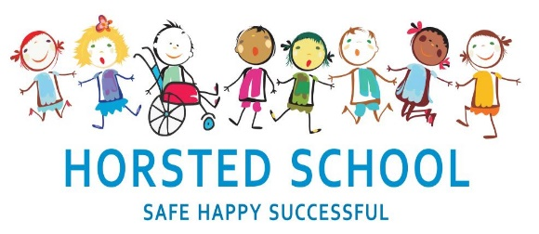
Swingate Primary School and Horsted Schools
Proposal to Federate Consultation Document
November 2nd 2021 – December 14th 2021

Contents Page

Page 3 – 4 | Brief background and summary rationale for federating
Page 5 – 6 | Letter from Chair of Governors of Swingate Primary School and Horsted Schools
Page 7 – 8 | Vision and Values of Schools and Federation
Page 9 – 15 | Proposal Details
Page 16 – 17 | How will this affect my children?
Page 18 – 19 | Opportunities to have your say
Page 20 | Meetings and Key Dates
Page 21 – 22 | FAQ
Page 23 | Due Diligence
Page 24 | Appendix 1 – Governance Structure
Page 25 | Appendix 2 Horsted Leadership Structure
Page 26 | Appendix 3 Swingate Leadership Structure
Page 27 | Appendix 4 Proposed key dates for Federation

Brief background and summary rationale
In December 2020 the long-standing Head Teacher at Swingate Primary School retired. The Governing Body at Swingate Primary School contacted the Local Authority to ask for some support for the remaining leadership team in place at Swingate Primary School. The Local Authority helped to broker the support of Horsted School and the experienced Head Teacher Steve Geary. From knowing both schools well the Local Authority suggested asking Steve as the schools held very similar values and shared a similar ethos. Both schools are child centred with an overriding drive to ensure all pupils meet their potential.
Since the partnership began in January 2021 many benefits have emerged from the schools working together. The benefits have been overwhelmingly mutual with Horsted Schools gaining as much from the partnership as Swingate Primary School. The schools have carried out curriculum enhancement, EYFS development, safeguarding support, financial support as well as the more day to day benefits of sharing resources and expertise. This led both Governing Bodies to consider if this partnership could be formalised in line with Medway Local Authority and the Governments national education policy.
The Government believes that to raise standards in schools, institutions should work together and schools are being strongly encouraged to do so. This national drive for schools to collaborate is an essential part of the future of education provision and is reflected in the Government’s Strategy and various initiatives.
The Governing Bodies of both schools also believe that collaboration enables schools to share expertise, good practice and ideas for innovation and provides support and opportunities for developing leadership, as well as tackling issues of inclusion and narrowing of the achievement gap.
One way of formalising partnership working between schools is for them to form Federations. After much research the Governing Bodies of both Horsted Schools and Swingate Primary School believe that Federating will bring huge benefits to the children of both schools.
Federations positively impact on standards by sharing responsibility for improving learning, behaviour, and delivering personalised learning. This is achieved by realising the benefits of being part of a wider professional community with shared values and aims.
Federating will deliver significant improvements in learner outcomes by facilitating:
- The delivery of an enriched curriculum that is broader and richer than any single institution, to meet the diverse range of learning needs.
- Leadership development allowing the Executive Headteacher more time to focus on strategic issues.
- Development of senior leadership team to provide leaders for the future
- The sharing of expert staff and resources to enrich the opportunities of pupils.
- Economies of scale through the joint purchasing of goods and contracting of service.
- New leadership and governance models determined by the need of the Federation.

The essential features for a successful Federation include:
- Sense of shared identity and common purpose.
- A strong cohesive leadership across all levels of the schools.
- The capacity to deliver (strong management infrastructure).
- A willingness to operate in a united way.
- A commitment of both time and resources to ensure Federation success.

Each school will retain its own separate identity in respect of its budget, admissions, performance tables and inspection by OFSTED but we strongly believe that the whole will be stronger than the sum of its parts.
The Governing Bodies of both schools fully support the federating of Horsted Schools and Swingate Primary School.

Joint letter from Swingate and Horsted Chair of Governors
November Month 2021
Dear Parents and Carers
We hope you and your child(ren) have enjoyed the return to school. As you are aware Horsted and Swingate Primary Schools have been working closely together since January 2021 with Mr Geary seconded part-time from Horsted to Swingate as Executive Headteacher. Both schools have greatly benefited from this close partnership with benefits to teaching and learning and budgetary efficiencies, although this is currently only a temporary arrangement.
To continue this beneficial partnership, discussions between the Governing Bodies of the two schools have taken place and as a result we are proposing a Federation between the schools. This will formalise the partnership relationship between the two schools and allow staff currently in interim leadership positions the opportunity to be appointed on a permanent basis. This will allow both schools to continue to work together on a formal and permanent basis and to continue to provide excellent teaching and learning opportunities at both schools.
A Federation is not an Academy - both schools will remain independent Local Authority Maintained Schools, on their respective sites, with their own DfE numbers and Ofsted reports / ratings; the children will attend the same school as before and the schools will retain their own budgets.
One area that will see change is School Governance. There will be one Federation Board which will have strategic oversight of both schools. The Federation Board will adopt a hybrid governance model, details of which can be seen in appendix 1. There will also be a Monitoring and Strategy Group for each school focusing on issues pertinent to that school.
Contained in this document is the information for the full statutory consultation process which will commence today (2nd November 2021) and last for six weeks. This process is outlined in the attached consultation documents which gives greater detail of the proposal and meetings at the respective schools for you to share your views and ask further questions. Consultation responses must be done in writing either direct to the relevant school office for the attention of the Chair of the Horsted and Swingate Federation Working Party, through the email address provided
Horsted Schools - consultation@horstedschool.co.uk
Swingate Primary School - consultation@swingate.medway.sch.uk
or through this Consultation Response form
https://forms.office.com/r/5JD9rrpYCk
We believe this to be a very exciting proposal for the future of children’s education in both schools and we hope that you share our enthusiasm.
We have also developed a FAQ guide to the Federation process, which is at the end of this document, and on both school websites and will be updated regularly throughout the process.
www.horstedschool.co.uk
www.swingate.medway.sch.uk
Yours sincerely Yours sincerely

John Murdoch Stephen Roe
Chair of Governors Chair of Governors
Swingate Primary School Horsted Primary School

The Federation
Our overriding aim is to ensure our senior leadership teams have the tools they need to develop well rounded, confident and responsible
individuals who aspire to achieve their full potential. We passionately believe in the whole child and that every single child in our care
should be given the same opportunities to thrive and succeed.

Our schools are welcoming, happy, safe, and supportive learning environments in which everyone is equal and all achievements are celebrated. We believe that a happy child is a successful child. We are committed to providing a positive, safe and stimulating environment for children to learn, where all are valued. We intend that all children should enjoy their learning, achieve their potential and become independent life-long learners. They care about themselves and those around them. Our pupils leave us as outward looking individuals who contribute overwhelmingly positively to society and the community they live in.

Horsted Schools - SAFE – HAPPY – SUCCESSFUL
All children are made aware from entry into foundation stage and throughout their time at school how to be a Horsted Learner.
- Think for ourselves
- Want to know more
- Never give up
- Always listen
- Support others
- Think hard. Work hard
- Have fun learning
Each child is seen as an individual and is encouraged to develop at his/her own rate to achieve their potential through planned and differentiated learning.
Horsted is an inclusive school. We strive to ensure that all children will be able to access the curriculum or make necessary modification to it in order to achieve this.
We are all S.T.A.R.S
Striving (they will be determined, persevere and they will be resilient);
Thoughtful (they will be creative, logical and curious about their world and those around them);
Aspirational (personally, emotionally and academically);
Respectful (of themselves, others and their environment);
Supportive (of themselves, others and their wider community).

Swingate Primary School - Excellent – Enjoyment - Everyone
Excellence
- We have engaging staff, pupils and families forming a cohesive team.
- We are all committed to outstanding teaching and learning
- We all have high expectations and outcomes, always
Enjoyment
- We provide enriching experiences and positive, happy role models.
- We celebrate the achievement of all.
- We support creativity and have fun.
Everyone
- We recognise that children, parents, families, staff and governors are all stakeholders in our school community.
- We strive to understand the needs of the wider community.
- Our leadership work to define and promote the shared values of our community.
- Believe, Learn and Achieve

Proposal Details
What this proposal covers
- The names of all the Governing Bodies wishing to federate together
- The proposed name of the new Federation
- Details of the proposed size of the Federation's Governing Body
- The identity of the admissions authority for the schools within the proposed Federation
- The date, not less than six weeks after the publication of the consultation proposal, by which written representations must be returned to the Governing Body - and the address to which they should be sent
- The nature and scope of the formal consultation process
- A draft Instrument of Government for Federated Governing Bodies
- The proposed governance structure for the Federation
- The proposed leadership structure for the Federation and its impact on the schools (including key HR issues arising from this)
- The nature of the engagement with the Local Authority
- The financial implications of federating
1 Governing Bodies wishing to Federate
1.1 The Governing Bodies of Swingate Primary School and Horsted Schools are proposing to form a Federation following a period of formal consultation as outlined in the sections that follow.

2 Name of the new Federation
2.1 We will be running a competition during the consultation between Year 5 and Year 6 of both schools to find an appropriate name.
3 The size of the Federation's governing body
3.1 The Federation Governing Body shall consist of 14 Governors as follows –
- 1 x Executive Headteacher
- 1 x Staff Governor
- 2 x Parent Governors (maximum to be elected)
- 1 LA Governor
- 9 Co-opted Governor

All members of the current governing bodies of Swingate Primary School and Horsted Schools are eligible to join this group
3.2 The new Federation Governing Body will be able to invite additional associate members as required to provide a strong skill set and ensure strong governance.
4 The admissions authority
4.1 Medway Council the Local Authority will remain the admissions authority for both schools within the Federation. The Federation will comply with the existing Medway Admissions Policy.
5. The dates for formal consultation
The formal consultation will remain open for 6 school weeks, to enable written representations to be made to the respective Governing Bodies.
Proposal published and formal consultation opens on Monday 2nd November 2021. Deadline for written representations to Governing Bodies on Thursday 14 ^{th} December 2021 at 12.00
6. Nature and scope of formal consultation
6.1 Both Governing Bodies are committed to meaningful stakeholder engagement throughout their respective consultation periods.
6.2 Although the timing of the formal consultation is synchronised between the two schools, each consultation is discrete to each school. As such, any written representations should be made to the relevant Local Governing Body and will be considered at this local level in order to maintain impartiality and reach a decision that is right for each school community.
6.3 In both schools, the formal consultation will consist of:
- Publication of this proposal on the schools’ websites.
- Copies electronically sent to all parents outlining the consultation. (Hard copies can be requested from the relevant school office).
- Drop in question sessions in each school
- A scheduled parents’ consultation evening in each school.
- A scheduled staff consultation meeting in each school.
- Submission of this proposal to the Local Authority.
- Copy of this proposal document forwarded to all main teaching and support staff trade unions.
- Carefully planned student involvement (through existing student council) to involve students in the rationale and impact on them.
- Copy of this document along with covering letter signed by both Governing Bodies sent to the Secretary of State, local schools and Members of Parliament within one week of opening consultation.
7.2 Draft Terms of Reference will be formed once new Federation Governing Body has been formed.
8 Proposed governance structure
8.1 The Federation will have one overarching Governing Body with governance responsibility and accountability across both schools.
8.2 There will also be a Monitoring and Strategy Group for each school focusing on issues pertinent to that school.
9 Proposed leadership structure
The detailed leadership structure of both schools can be found in Appendix 3 and 4.
9.1 The leadership structure of the Federation will have one permanent Executive Headteacher who works across both schools. This person will be the legally named Executive Headteacher of both schools and therefore will hold a Headteacher contract with the appropriate person specification and job description. This Headteacher contract will be held by the newly formed Federation.
9.2 Each school shall have its own individual Head of School to ensure operational consistency at local community level and a constant point of contact for students, staff and parents in each school.
9.4 Staff will continue to be employed by their respective schools with each school retaining contracts for staff they currently employ. New staff will be employed by the Federation.
9.5 Although there are no plans to change staffing structures of either school below the Head of School level as a result of this Federation proposal, however both Governing Bodies recognise that if this proposal goes ahead there may opportunities for both schools to save money by the sharing of resources including staff.
9.6 If this proposal to Federate goes ahead the Governors recognise that one of the potential benefits is sharing expertise. This may include asking existing staff to work across both schools. However, this is not something which would be imposed; decisions would be based upon consultation and negotiation with the member of staff in question. In the future new staff will be appointed by the Federation to work across both schools.

10 Engagement with the Local Authority
10.1 Both schools have worked closely with representatives from the Local Authority (LA) throughout the pre-consultation process. The LA has provided advice and guidance on the Federation process itself as well as contributing to the discussions around the potential school improvement benefits that such Federation could bring.
10.2 The LA has been invited to attend the joint Governor working party and have agreed to support the appointment of an LA Governor to the new Federation Governing Body.
10.3 The schools have brokered specialist HR and pay advice and will continue to do so if the proposal progresses towards implementation following consultation.
10.4 The Local Authority and The Education People have provided specialist legal advice with regard to the consultation process.
11 The financial implications of Federating
11.1 Although Federation will mean a single governance structure across both schools, each school will remain separate in terms of funding allocation from the LA.
11.2 It is anticipated that there will be some potential cost savings achieved through joint procurement of services, goods and training.
11.3 As LA schools, the LA retains overall responsibility for the financial viability of both schools. In-year and carry forward deficits or surplus remain with the individual schools.
11.4 The costs/savings related to the proposed Federation leadership structure in section 9 of this document (Executive Headteacher) will be equally shared by both schools.
11.5 The Federation Governing Body would be responsible for ensuring that the budget for each school would balance and would not use the budget of one school to disadvantage the other. It may decide to ‘pool’ a small proportion of each school’s individual budgets if it meant that both schools would get better value for money, through the joint procurement of a service

How will this affect me and my children?
Initially, and day to day, you and your children will not see a great deal of difference at either school. The children will still go to the same school, in the same uniform with the same teachers. However, as the Federation becomes established your children can expect to see an enriched learning experience due to opportunities to share expertise and facilities, Increased capacity to meet the needs of children through the sharing of knowledge and resources and cross-school development of the curriculum. Improved continuity of staffing and leadership due to the opportunity to grow and retain our best leaders by moving leaders across schools within the Federation where they might otherwise have left us. A consistent approach to teaching and learning, tailored to the needs of pupils in each school. The opportunity to take part in inter-school competitions and extra-curricular activities; to gain broader experiences through inter-school working and to feel part of a wider cross school community. The capacity to make recruitment to our schools more attractive so our children are taught by the best teachers available, and who also contribute to the future improvement of our schools.
What would the new Federation mean for staff?
The Federation will bring a great deal of benefits for staff and consequently the pupils. There will be an increased opportunity for continuing professional development and career advancement. Staff networks across the three schools, giving opportunities to train together, share ideas and learn from each other. Enhanced opportunity for identifying and applying best practice across the Federation. Increased opportunities to gain experience within our family of schools. Greater breadth of support for Early Career Teachers.
The temporary leadership structures that have been put in place during our current partnership would become permanent, giving stability and security for pupils, parents and staff. Governance arrangements would reflect the reality of a leadership team that works across the schools. This will provide better support and challenge for the leadership team and will make accountability stronger.
Learning should be enjoyable, allowing children to achieve their potential and helping them become lifelong learners who are ready and able to grasp opportunities. Staff in the Federation should be lifelong learners too, always looking for ways to develop their skills for their own benefit and for the children they work with. The schools will continue to promote the emotional, moral, spiritual, and physical development of the children at the school. We will work in partnership with outside agencies and our communities to ensure ongoing development and learning.

Opportunities to have your say
The working party and the Governing Bodies of each school believe transparency and openness should be the undelaying principle running through the consultation process.
We believe that all stakeholders should be given every opportunity to make their views known in regards to proposed federation of Horsted Schools and Swingate Primary School.
We will be holding 4 drop-in sessions where any stakeholder will be able to pop in ask questions of the Governors and the Acting Executive Headteacher.
These will be held on
Swingate Primary School Parents Evening  (Drop in sessions) | Thursday 4th November 2021
Horsted Schools Parents Evening  (Drop in sessions) | Thursday 11th November 2021
Drop in Session for Swingate | Thursday 25th November 2021  3.30 – 4.30 pm
Drop in Session for Horsted | Wednesday 24th November 2021  3.30 – 4.30 pm
Evening Presentation for wider community at Swingate | Thursday 9th December 2021  6.00 – 7.00 pm
Evening Presentation for wider community at Horsted | Wednesday 8th December 2021  6.00 – 7.00 pm

We have also created a dedicated email address for consultation feedback. The email address is –
consultation@horstedschool.co.uk
consultation@swingate.medway.sch.uk
We have also created an online form which where you can answer questions and make your views known. The form can be accessed through the below link.
https://forms.office.com/r/5JD9rrpYCk
The Acting Executive Headteacher and Governors from the Federation working party are also available by appointment through contacting the office at either school on
Swingate Primary School – consultation@swingate.medway.sch.uk - Telephone 01634 863778
Horsted Primary School – consultation@horstedschool.co.uk – Telephone 01634 335400
Please come alone to one of the drop-in sessions and ask as many questions as you like. We would genuinely welcome any and all feedback.
The consultation document and links to feedback forms can be found at –
www.horstedschool.co.uk
www.swingate.medway.sch.uk

Record of Meetings and Key dates
Date | Meeting | Minutes Available
Monday 19th July 2021 | First meeting of the Federation Working Party | Yes
Tuesday 12th October 2021 | Second meeting of the Federation Working Party | No
Thursday 21st October 2021 | Third meeting of the Federation Working Party | Yes
Monday 1st November | Swingate Staff meeting to explain about the federation process – STAFF ONLY | No
Monday 1st November | Horsted Staff meeting to explain about the federation process – STAFF ONLY | No
Tuesday 2nd November 2021 | Federation consultation period opens
Thursday 9th December 2021 | Consultation drop in session with Executive Head Teacher and governor from the working party. To be held at Swingate Primary School
Wednesday 8th December | Consultation drop in session with Executive Head Teacher and governor from the working party. To be held at Horsted School.
Wednesday 24th November | Public consultation presentation at Swingate Primary School
Tuesday 14th December | Federation consultation period closes
Thursday 13th January | Federation Working Party meeting to discuss consultation responses

Frequently Asked Questions (FAQ’s) – To be updated weekly during the consultation period
What is a Federation?
A Federation is a formal agreement between two or more schools to work together on a permanent basis. The partnership has a Federated Board which is made up of representatives from both schools. Each of the schools in the Federation receives their own budget, receive separate Ofsted inspection reports and has separately published results. The uniqueness and individuality of each school is maintained.

What is an Executive Headteacher?
Executive Headteachers provide strategic leadership across two or more schools; they are supported by leadership in each individual school in the partnership.
The Executive Headteacher would have an overview of both schools and would be helping both to improve by:
- working together to tackle shared priorities; addressing individual school priorities by benefitting from good practice in the partner school;
- and streamlining practice, background management, and support
functions to give a sharper focus on teaching and learning.

What would be the impact on staff, including those who provide support services to the school? (caretakers, cleaning, catering etc)
Other than leadership roles, there are no immediate plans to change the staffing structure or services in either school but over time we may seek to share staff as roles become vacant or new ones are created.

Would staff get the opportunity to work at both schools?

This is one of the potential benefits in terms of developing staff and sharing expertise. We would encourage this where it was beneficial and met school improvement priorities. However, this is not something which would be imposed; decisions would be based upon consultation and negotiation.
In the future, new staff would be appointed to the Federation, which makes them available to work at both sites.
Does Federating the schools ultimately cost them more money?
No - in fact, it provides schools with opportunities to share costs and gain access to staffing and resources that might not otherwise be available to an individual school.
Is this just a government cost cutting exercise?
No – the recommendation to Federate has been reached jointly be the Governing Body of both schools; no external influence has been applied.
The funding of schools is primarily based on pupil numbers and as these numbers would not be affected by Federating, the school budgets would remain the same.
Can a Federation be dissolved?
Yes - De-Federation is a straightforward process if two schools decide to separate again. It is considered good practice for a Federation to be reviewed every year.

Due Diligence
As part of the federation process the Governing Bodies of each school have carried out a process of due diligence to ensure that both schools are in healthy position in terms of a number of criteria including finances and how well the pupils achieve on a number of key tests. The Governing Bodies of each school have produced the table below to show the positions of each school. The Governing Bodies of each school are satisfied that the due diligence process has been carried out satisfactorily by each school.

 | Horsted School | Swingate Primary School
Key Performance Indicators (latest data) | EYFS – 80% - (National 71.8%)  Year 1 Phonics – 83% (National – 82%)  Year 2 Reading – 87% (National – 73%)  Year 2 Maths – 85% (National - 76%)  Year 2 Writing – 82% (National 62%)  Year 6 Reading – 85% (National 73%)  Year 6 Maths – 93% (National 79%)  Year 6 Writing – 84% (National 78%)  Year 6 combined - 77% (National 65%) | EYFS – 74% - (National 71.8%)  Year 1 Phonics – 90% (National – 82%)  Year 2 Reading – 75% (National – 73%)  Year 2 Maths – 76% (National - 76%)  Year 2 Writing – 69% (National 62%)  Year 6 Reading – 83% (National 73%)  Year 6 Maths – 93% (National 79%)  Year 6 Writing – 91% (National 78%)  Year 6 combined - 73% (National 65%)
Narrative | This data is from 2019 – the latest data we have due to the pandemic
Attendance | Year to date is  Juniors – 96.8  Infants - 98% | Year to date is 96.84%
Narrative | Medway would like attendance to be 96%+. Schools generally aim for 97%.
SEND Narrative | The schools have comparable SEND data
Finance | The finance of both schools has been scrutinised by the Federation Working Party. Both schools are in a healthy financial position and consistently carry across positive balance sheets year after year.
Safeguarding | Horsted School is safeguarding compliant. Policies are up to date and are readily available on the website.  Engagement with social services is high and referrals are appropriately made and followed through. | Swingate School is safeguarding compliant. Policies are up to date and are readily available on the website.  Engagement with social services is high and referrals are appropriately made and followed through. Swingate has used CPOMS for a number of years are confident with the programme.
Narrative | Horsted has recently moved to CPOMS training programme which Swingate is helping with. | Swingate has recently been involved in a pilot audit of safeguarding provision and performed very well through the process.
a
Admissions | 78 pupils chose Horsted as a first choice preference. This is out a maximum number of 60. | 82 pupils chose Swingate as first choice preference. This is out a maximum of 90 places.
Health and Safety | Horsted has a good Health and Safety record. Covid Risk Assessments are in place and staff appropriately trained in first aid and positive handling. Health and safety walks are regularly undertaken. There are no on-going health and safety concerns at Horsted School. | Swingate has a good Health and Safety record. Covid Risk Assessments are in place and staff appropriately trained in first aid and positive handling. Health and safety walks are regularly undertaken. There are no on-going health and safety concerns at Swingate School.
Human Resources | Both schools are compliant with their Human Resources provision as we both use KAPE. | Both schools are compliant with their Human Resources provision as we both use KAPE.

Appendix 1

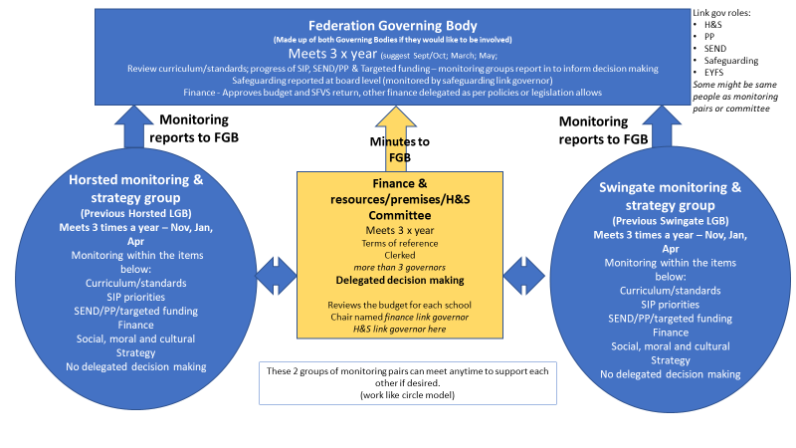
Appendix 2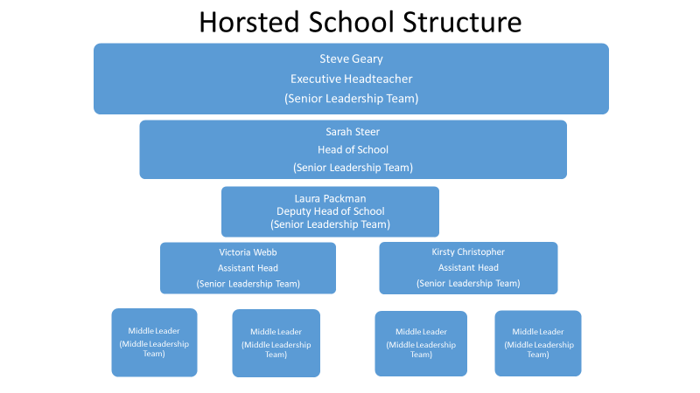
Appendix 3.
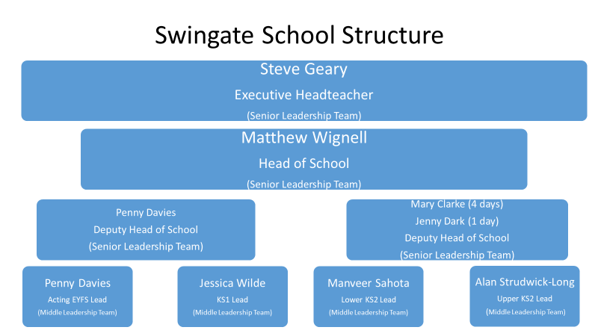

Appendix 4.
Proposed key dates for Federation
Start of consultation period | 2nd November 2021
End of consultation period | 14th December 2021
Working Party Meeting to review feedback from consultation | 13th January 2022
Letter to staff, parents and interested parties regarding the result of the consultation | Week beginning 24th January 2022
If the consultation is positive  Dissolve the individual governing bodies of Horsted Schools and Swingate Primary School | April 1st 2022
If the consultation is positive  The Federation is legally formed | April 1st 2022

